|  |
| --- |
| VLSI LAB MANUAL (18ECL77) 2022-23 |
|  |
| EC DEPT, DSATM, BANGALORE-560082 |
|  |
|  |

|  |
| --- |

| **B. E. ECE**  **Choice Based Credit System (CBCS) and Outcome Based Education (OBE) SEMESTER – VII** | | | |
| --- | --- | --- | --- |
| **VLSI LAB** | | | |
| **Course Code** | **18ECL77** | **CIE Marks** | **40** |
| **Number of Lecture Hours/Week** | **02Hr Tutorial (Instructions)**  **+ 02 Hours Laboratory** | **SEE Marks** | **60** |
| **RBT Levels** | **L1, L2, L3** | **Exam Hours** | **03** |
| **CREDITS – 02** | | | |
| **Course Learning Objectives:** This course will enable students to:   * Design, model, simulate and verify CMOS digital circuits * Design layouts and perform physical verification of CMOS digital circuits * Perform ASIC design flow and understand the process of synthesis, synthesis constraints and evaluating the synthesis reports to obtain optimum gate level netlist * Perform RTL-GDSII flow and understand the stages in ASIC design | | | |
| **Experiments can be conducted using any of the following or equivalent design tools: Cadence/Synopsis/Mentor Graphics/Microwind** | | | |
| **Laboratory Experiments Part – A**  **Analog Design**  **Use any VLSI design tools to carry out the experiments, use library files and technology files below 180 nm.** | | | |
| 1. a) Capture the schematic of CMOS inverter with load capacitance of 0.1pF and set the widths of inverter with Wn = Wp, Wn = 2Wp, Wn = Wp/2 and length at selected technology. Carry out the following:    1. Set the input signal to a pulse with rise time, fall time of 1ns and pulse width of 10ns and time period of 20ns and plot the input voltage and output voltage of designed inverter?    2. From the simulation results compute tpHL, tpLH and td for all three geometrical settings of width?    3. Tabulate the results of delay and find the best geometry for minimum delay for CMOS inverter?   1. b)Draw layout of inverter with Wp/Wn = 40/20, use optimum layout methods. Verify for DRC and LVS, extract parasitic and perform post layout simulations, compare the results with pre-layout simulations. Record  the observations. | | | |
| 2. a) Capture the schematic of 2-input CMOS NAND gate having similar delay as that of CMOS inverter computed in experiment 1. Verify the functionality of NAND gate and also find out the delay td for all four possible combinations of input vectors. Table the results. Increase the drive strength to 2X and 4X and tabulate the results.  2.b)Draw layout of NAND withWp/Wn = 40/20, use optimum layout methods. Verify for DRC and LVS, extract parasitic and perform post layout simulations, compare the results with pre-layout simulations. Record the observations. | | | |
| 3.a) Capture schematic of Common Source Amplifier with PMOS Current Mirror Load and find its transient response and AC response? Measures the Unity Gain Bandwidth (UGB), amplification factor by varying transistor geometries, study the impact of variation in width to UGB.  1. b) Draw layout of common source amplifier, use optimum layout methods. Verify for DRC and LVS, extract parasitic and perform post layout simulations, compare the results with pre-layout simulations. Record the observations. | | | |
| 1. a)Capture schematic of two-stage operational amplifier and measure the following:    1. UGB    2. dB bandwidth    3. Gain margin and phase margin with and without coupling capacitance    4. Use the op-amp in the inverting and non-inverting configuration and verify its functionality    5. Study the UGB, 3dB bandwidth, gain and power requirement in op-amp by varying the stage wise | | | |
| transistor geometries and record the observations.  4. b) Draw layout of two-stage operational amplifier with minimum transistor width set to 300 (in 180/90/45 nm technology), choose appropriate transistor geometries as per the results obtained in 4.a. Use optimum layout methods. Verify for DRC and LVS, extract parasitic and perform post layout simulations, compare the results  with pre-layout simulations. Record the observations. | | | |
| **Part - B Digital Design**  **Carry out the experiments using semicustom design flow or ASIC design flow, use technology library 180/90/45nm and below**  **Note: The experiments can also be carried out using FPGA design flow, it is required to set appropriate**  **constraints in FPGA advanced synthesis options** | | | |
| 1. Write verilog code for 4-bit up/down asynchronous reset counter and carry out the following:    1. Verify the functionality using test bench    2. Synthesize the design by setting area and timing constraint. Obtain the gate level netlist, find the critical path and maximum frequency of operation. Record the area requirement in terms of number of cells required and properties of each cell in terms of driving strength, power and area requirement.    3. Perform the above for 32-bit up/down counter and identify the critical path, delay of critical path, and maximum frequency of operation, total number of cells required and total area. | | | |
| 2.Write verilog code for 4-bit adder and verify its functionality using test bench. Synthesize the design by setting proper constraints and obtain the net list. From the report generated identify critical path, maximum delay, total number of cells, power requirement and total area required. Change the constraints and obtain  optimum synthesis results. | | | |
| 1. Write verilog code for UART and carry out the following:    1. Perform functional verification using test bench    2. Synthesize the design targeting suitable library and by setting area and timing constraints    3. For various constrains set, tabulate the area, power and delay for the synthesized netlist    4. Identify the critical path and set the constraints to obtain optimum gate level netlist with suitable constraints | | | |
| 1. Write verilog code for 32-bit ALU supporting four logical and four arithmetic operations, use case statement and if statement for ALU behavioral modeling.    1. Perform functional verification using test bench    2. Synthesize the design targeting suitable library by setting area and timing constraints    3. For various constrains set, tabulate the area, power and delay for the synthesized netlist    4. Identify the critical path and set the constraints to obtain optimum gate level netlist with suitable constraints   Compare the synthesis results of ALU modeled using IF and CASE statements. | | | |
| 5. Write verilog code for Latch and Flip-flop, Synthesize the design and compare the synthesis report (D, SR, JK). | | | |
| 1. For the synthesized netlist carry out the following for any two above experiments:    1. Floor planning (automatic), identify the placement of pads    2. Placement and Routing, record the parameters such as no. of layers used for routing, flip method for placement of standard cells, placement of standard cells, routes of power and ground, and routing of standard cells    3. Physical verification and record the LVS and DRC reports    4. Perform Back annotation and verify the functionality of the design    5. Generate GDSII and record the number of masks and its color composition | | | |
| **Course Outcomes:** On the completion of this laboratory course, the students will be able to:   * Design and simulate combinational and sequential digital circuits using Verilog HDL * Understand the Synthesis process of digital circuits using EDA tool. * Perform ASIC design flow and understand the process of synthesis, synthesis constraints and evaluating the synthesis reports to obtain optimum gate level net list * Design and simulate basic CMOS circuits like inverter, common source amplifier and differential amplifiers. * Perform RTL-GDSII flow and understand the stages in ASIC design. | | | |

| **Part-A Analog Design Flow** | |
| --- | --- |
| **1** | **A CMOS inverter** |
| **2** | **2-input CMOS NAND gate** |
| **3** | **Common Source Amplifier** |
| **4** | **Two-stage operational amplifier** |
| **Part-B Digital Design Flow** | |
| **Sl No.** | **Name of the Experiment** |
| **1** | **4-bit Up/Down Asynchronous Reset Counter** |
| **2** | **4-bit Adder** |
| **3** | **UART** |
| **4** | **32-bit ALU** |
| **5** | **Flip-flop and Latch(D-FF/D-Latch, JK-FF/JK-Latch, SR-FF/SR-Latch)** |
| **6** | **Physical Design (for two experiments)** |

**Course Outcomes**

| On the completion of this laboratory course, the students will be able to: | |
| --- | --- |
| CO1 | Design and simulate combinational and sequential digital circuits using Verilog HDL |
| CO2 | Analyze the Synthesis process of digital circuits using EDA tool. |
| CO3 | Perform ASIC design flow and understand the process of synthesis, synthesis constraints and evaluating the synthesis reports to obtain optimum gate level net list |
| CO4 | Design and simulate basic CMOS circuits like inverter, common source amplifier and Operational Amplifier. |
| CO5 | Perform RTL-GDSII flow and understand the stages in ASIC design. |

**PART B: ASIC – Digital Design Flow**

**PROCEDURE FOR CREATING DIGITAL SIMULATION USING VERILOG AND CADENCE DIGITAL TOOL**

Open Terminal Window and use the following commands

**Procedure for Simulation:**

1**. Change directory to Cadence_Digital_labs/Workarea/Inverter using commands:**

>**csh**

>**source /home/install/cshrc**

2. Type the programs design code and testbench code using editor in workarea folder and save

### Create the design file (Verilog module) using editor gedit

>**gedit filename.v**

The file name can be changed with respect to the experiments.

### Create the testbench file (Verilog module) using editor gedit

>**gedit tb_filename.v**

The testbench file name can be changed with respect to the design file.

3. **Compile the source Descriptions: (i) Compile the Inverter description with the -messages option:**

>ncvlog –mess (**name of the file**) (**name of the testbench file**)

Example: >**ncvlog -mess inv.v tb_inv.v**

Note: Check out for error and warnings. If any, then go back to text editor and edit and the compile

4. **Elaborate the top level Design using the command:**

>**ncelab -mess -access +rwc (name of the testbench file without file type)**

Example: **>ncelab -mess –access +rwc tb_inv** **//Do not include file type (.v) for testbench file**

5. **Simulate the Top-Level Design in Non GUI mode**

>**ncsim -mess -gui (name of the testbench file)**

**Example:>ncsim -mess -gui tb_inv**

**Now a console and Design Browser windows of Simvision are opened and click on the waveform button in the toolbar to send the selected objects to waveform window.**

**Waveform Window opens and Press run to run the simulation for a time period specified in the time field.**

#### Procedure for Synthesis using Cadence Tool

The Verilog code, technology library and the constraint files are input to the logical synthesis. The tool will generate the gate level netlist and gives the output as: gatelevel schematic and the report of area, power and timing.

**6. Create a file named Contraints_sdc.sdc**

**The timing constraints are defined in this file. Example of one such file is as shown –**

**create_clock -name clk -period 10 -waveform {0 5} [get_ports "clk"]**

**set_clock_transition -rise 0.1 [get_clocks "clk"]**

**set_clock_transition -fall 0.1 [get_clocks "clk"]**

**set_clock_uncertainty 1.0 [get_ports "clk"]**

**set_input_delay -max 1.0 [get_ports "A"] -clock [get_clocks "clk"]**

**set_input_delay -max 1.0 [get_ports "B"] -clock [get_clocks "clk"]**

**set_output_delay -max 1.0 [get_ports "sum"] -clock [get_clocks "clk"]**

**There are three different parts in the constraint file:**

**a.** Clock definition and clock constraints –

**Clock definition**

**create_clock -name clk -period 10 -waveform {0 5} [get_ports "clock"]**

**Clock rise time**

**set_clock_transition -rise 0.1 [get_clocks " clk "]**

**Clock fall time**

**set_clock_transition -fall 0.1 [get_clocks " clk "]**

**Uncertainties of Clock**

**set_clock_uncertainty 1.0 [get_ports " clk "]**

**b. Input port timing constraints –**

**set_input_delay -max 1.0 [get_ports " A"] -clock [get_clocks " clk "]**

**Input port delay**

**set_input_delay -max 1.0 [get_ports " B"] -clock [get_clocks " clk "]**

**Input port delay**

**c. Output port timing constraints –**

**Output port delay**

**set_output_delay -max 1.0 [get_ports " sum "] -clock [get_clocks " clk "]**

**The port names that are used in the constraint file (bolded) must match with the names that are used in the Verilog program of the main design module. The constraints are defined for all the ports in the design.**

**7. Synthesis the top level design**

The verilog file to be synthesized must be copied into this directory.

**Copy genus.tcl file that created for simulation in desktop into user directory**

**genus.tcl file contains**

read_lib

read_hdl **counter_8bit.v** (example)

elaborate

read_sdc top.sdc

syn_generic

write_hdl

syn_map

write_hdl

write_hdl>syn_netlist.v

write_sdc>syn_sdc.sdc

gui_show

report area>area_rep

report gates>gates_rep

report timing>timing_rep

**Synthesize the top level design**

**Open the genus.tcl file in gedit**

**>gedit genus.tcl**

**Change the filename in read_hdl**

**read_hdl {filename.v} // filename.v is the Design code file**

**{inv.v} // for example inv.v as filename.v**

Then invoke **genus** command

**>genus -f genus.tcl**

**Script file contains the Verilog RTL code, standard library file for a particular technology,**

**Introduction to Constraints and Synthesis Commands**

**SDC**Synopsys Design Constraint (SDC) format is used to specify the design intent, including the timing and area constraints of the design.

**1. create_clock**Usage  
create_clock [-add] [-name <clock_name>] -period <value> [-waveform <edge_list>]   
<targets>  
Options  
-add: Adds clock to a node with an existing clock  
-name <clock_name>: Clock name of the created clock  
-period <value>: Speed of the clock in terms of clock period  
-waveform <edge_list>: List of edge values  
<targets>: List or collection of targets

**Description**Defines a clock. If the -name option is not used; the clock name is the same as the first target in the list or collection. The clock name is used to refer to the clock in other commands.

The -period option specifies the clock period. It is also possible to use this option to specify a frequency to define the clock period. This can be done by using -period option followed by either <frequency>MHz or "<frequency> MHz".

The -waveform option specifies the rising and falling edges (duty cycle) of the clock, and is specified as a list of two time values: the first rising edge and the next falling edge. The rising edge must be within the range [0, period]. The falling edge must be within one clock period of the rising edge. The waveform defaults to (0, period/2).

If a clock with the same name is already assigned to a given target, the create_clock command will overwrite the existing clock. If a clock with a different name exists on the given target, the create_clock command will be ignored unless the -add option is used. The -add option can be used to assign multiple clocks to a pin or port.

If the target of the clock is internal (i.e. not an input port), the source latency is zero by default. If a clock is on a path after another clock, then it blocks or overwrites the previous clock from that point forward.

Example  
# Create a simple 10ns with clock with a 60% duty cycle  
create_clock -period 10 -waveform {0 6} -name clk [get_ports clk]

# Create a clock with a falling edge at 2ns, rising edge at 8ns,  
# falling at 12ns, etc.  
create_clock -period 10 -waveform {8 12} -name clk [get_ports clk]

1. get_clocks  
   Usage  
   get_clocks [-nocase] [-nowarn] <filter>  
   Options  
   -nocase: Specifies the matching of node names to be case-insensitive  
   -nowarn: Do not issue warnings messages about unmatched patterns  
   <filter>: Valid destinations (string patterns are matched using Tcl string matching)

Description  
Returns a collection of clocks in the design. When used as an argument to another command, such as the -from or -to options of set_multicycle_path, each node in the clock represents all nodes driven by the clocks in the collection.

1. get_ports  
   Usage  
   get_ports [-nocase] [-nowarn] <filter>  
   Options  
   -nocase: Specifies case-insensitive node name matching  
   -nowarn: Do not issue warnings messages about unmatched patterns  
   <filter>: Valid destinations (string patterns are matched using Tcl string matching)

Description  
Returns a collection of ports (design inputs and outputs) in the design.  
The filter for the collection is a Tcl list of wildcards, and must follow standard Tcl

1. set_clock_uncertainty  
   Usage  
   set_clock_uncertainty [-add] [-fall_from <fall_from_clock>] [-fall_to <fall_to_clock>] [-from <from_clock>] [-hold] [-rise_from <rise_from_clock>] [-rise_to <rise_to_clock>] [-setup] [-to <to_clock>] <uncertainty>

Options  
-add: Specifies that this assignment is an addition to the clock uncertainty derived by derive_clock_uncertainty call  
-fall_from <fall_from_clock>: Valid destinations (string patterns are matched using Tcl string matching)  
-fall_to <fall_to_clock>: Valid destinations (string patterns are matched using Tcl string matching)  
-from <from_clock>: Valid destinations (string patterns are matched using Tcl string matching)  
-hold: Specifies the uncertainty value (applies to clock hold or removal checks)  
-rise_from <rise_from_clock>: Valid destinations (string patterns are matched using Tcl string matching)  
-rise_to <rise_to_clock>: Valid destinations (string patterns are matched using Tcl string matching)  
-setup: Specifies the uncertainty value (applies to clock setup or recovery checks)   
(default)  
-to <to_clock>: Valid destinations (string patterns are matched using Tcl string matching)  
<uncertainty>: Uncertainty

Description  
Specifies clock uncertainty or skew for clocks or clock-to-clock transfers. You can specify uncertainty separately for setup and hold, and can specify separate rising and falling clock transitions. The setup uncertainty is subtracted from the data required time for each applicable path, and the hold uncertainty is added to the data required time for each applicable path.

The values for the -from, -to, and similar options are either collections or a Tcl list of wildcards used to create collections of appropriate types. The values used must follow standard Tcl

When -add option is used, clock uncertainty assignment is treated as an addition to the value calculted by derive_clock_uncertainty command for a particular clock transfer.

Note that when -add option is not used and derive_clock_uncertainty is called, user specified clock uncertainty assignment will take priority. When derive_clock_uncertainty command is not used, specifying -add option to set_clock_uncertainty command will not have any effect.

1. set_input_delay  
   Usage  
   set_input_delay [-add_delay] -clock <name> [-clock_fall] [-fall] [-max] [-min] [-reference_pin <name>] [-rise] [-source_latency_included] <delay> <targets>  
   Options  
   -add_delay: Add to existing delays instead of overriding them  
   -clock <name>: Clock name  
   -clock_fall: Specifies that input delay is relative to the falling edge of the clock  
   -fall: Specifies the falling input delay at the port  
   -max: Applies value as maximum data arrival time  
   -min: Applies value as minimum data arrival time  
   -reference_pin <name>: Specifies a port in the design to which the input delay is relative  
   -rise: Specifies the rising input delay at the port  
   -source_latency_included: Specifies that input delay includes added source latency  
   <delay>: Time value  
   <targets>: List of input port type objects

Description  
Specifies the data arrival times at the specified input ports relative the clock specified by the -clock option. The clock must refer to a clock name in the design.  
Input delays can be specified relative to the rising edge (default) or falling edge (-clock_fall) of the clock.

If the input delay is specified relative to a simple generated clock (a generated clock with a single target), the clock arrival times to the generated clock are added to the data arrival time.

Input delays can be specified relative to a port (-reference_pin) in the clock network. Clock arrival times to the reference port are added to data arrival times. Non-port reference pins are not supported.

Input delays can already include clock source latency. By default the clock source latency of the related clock is added to the input delay value, but when the -source_latency_included option is specified, the clock source latency is not added because it was factored into the input delay value.

The maximum input delay (-max) is used for clock setup checks or recovery checks and the minimum input delay (-min) is used for clock hold checks or removal checks. If only -min or -max (or neither) is specified for a given port, the same value is used for both.

Separate rising (-rise) and falling (-fall) arrival times at the port can be specified. If only one of -rise and -fall are specified for a given port, the same value is used for both.

By default, set_input_delay removes any other input delays to the port except for those with the same -clock, -clock_fall, and -reference_pin combination. Multiple input delays relative to different clocks, clock edges, or reference pins can be specified using the -add_delay option.

1. set_input_transition  
   Usage  
   set_input_transition [-clock <name>] [-clock_fall] [-fall] [-max] [-min] [-rise]   
   <transition> <ports>  
   Options  
   -clock <name>: Clock name  
   -clock_fall: Specifies that input delay is relative to the falling edge of the clock  
   -fall: Specifies the falling output delay at the port  
   -max: Applies value as maximum data required time  
   -min: Applies value as minimum data required time  
   -rise: Specifies the rising output delay at the port  
   <transition>: Time value  
   <ports>: Collection or list of input or bidir ports

Description

It only affects PrimeTime analysis or HardCopy II devices. If you set this constraint in TimeQuest the constraint is written out to the SDC file when you call write_sdc

1. set_output_delay  
   Usage  
   set_output_delay [-add_delay] -clock <name> [-clock_fall] [-fall] [-max] [-min]   
   [-reference_pin <name>] [-rise] [-source_latency_included] <delay> <targets>  
   Options  
   -add_delay: Add to existing delays instead of overriding them  
   -clock <name>: Clock name  
   -clock_fall: Specifies output delay relative to the falling edge of the clock  
   -fall: Specifies the falling output delay at the port  
   -max: Applies value as maximum data required time  
   -min: Applies value as minimum data required time  
   -reference_pin <name>: Specifies a port in the design to which the output delay is relative  
   -rise: Specifies the rising output delay at the port  
   -source_latency_included: Specifies input delay already includes added source latency  
   <delay>: Time value  
   <targets>: Collection or list of output ports

Description  
Specifies the data required times at the specified output ports relative the clock specified by the -clock option. The clock must refer to a clock name in the design.  
Output delays can be specified relative to the rising edge (default) or falling edge (-clock_fall) of the clock.

If the output delay is specified relative to a simple generated clock (a generated clock with a single target), the clock arrival times to the generated clock are added to the data required time. Output delays can be specified relative to a port (-reference_pin) in the clock network. Clock arrival times to the reference port are added to the data required time. Non-port reference pins are not supported.  
Output delays can include clock source latency.

By default the clock source latency of the related clock is added to the output delay value, but when the - source_latency_included option is specified, the clock   
source latency is not added because it was factored into the output delay value.  
The maximum output delay (-max) is used for clock setup checks or recovery checks and the minimum output delay (-min) is used for clock hold checks or removal checks. If only one of -min and -max (or neither) is specified for a given port, the same value is used for both.

Separate rising (-rise) and falling (-fall) required times at the port can be specified. If only one of -rise and -fall are specified for a given port, the same value is used for both.

By default, set_output_delay removes any other output delays to the port except for those with the same -clock, -clock_fall, and -reference_pin combination. Multiple output delays relative to different clocks, clock edges, or reference pins can be specified using the -add_delay option.

TCL Command:

read_sdc  
Usage  
read_sdc [-hdl] <file_name>  
Options  
-hdl: Read SDC commands embedded in HDL  
<file_name>: Name of the SDC file

Description  
Reads an SDC file with all current constraints and exceptions. If an SDC file is specified, read_sdc only reads that SDC file. If the -hdl option is specified, read_sdc only reads SDC commands that were embedded in HDL.

If no arguments are specified, read_sdc reads the default SDC files along with any SDC commands that   
were embedded in HDL. If one or more SDC_FILE assignments exists in the QSF, read_sdc reads all of them in order. Otherwise, read_sdc reads the file <revision>.sdc if it exists.

Example  
project_new test  
create_timing_netlist  
# Read SDC commands from test_constraints.sdc  
read_sdc test_constraints.sdc

**Experiment-1**

**Title: 4-bit Up/Down Asynchronous Reset Counter**

**Problem Statement:** To write Verilog code for asynchronous counter circuit and its test bench for verification, observe the waveform and synthesize the code with technological library with given Constraints.

**Objective:**

**Write Verilog code for 4-bit up/down asynchronous reset counter and carry out the following:**

a. Verify the functionality using test bench

b. Synthesize the design by setting area and timing constraint. Obtain the gate level netlist, find the critical path and maximum frequency of operation. Record the area requirement in terms of number of cells required and properties of each cell in terms of driving strength, power and area requirement.

c. Perform the above for 32-bit up/down counter and identify the critical path, delay of critical path, and maximum frequency of operation, total number of cells required and total area.

**TOOL REQUIRED:** Cadence Tool

**THEORY:**

Asynchronous counters are those whose output is free from the clock signal. Because the flip flops in asynchronous counters are supplied with different clock signals, there may be delay in producing output.

The required number of logic gates to design asynchronous counters is very less. So they are simple in design. Another name for Asynchronous counters is “Ripple counters”.

A ripple counter is an asynchronous counter where only the first flip-flop is clocked by an external clock. All subsequent flip-flops are clocked by the output of the preceding flip-flop. Asynchronous counters are also called ripple-counters because of the way the clock pulse ripples it way through the flip-flops.

4-bit up/down Counter with loadable count

A counter is a sequential circuit which is used to count clock pulses. In other words, a counter is a sequential machine constructed with the help of flip-flops & changes its state according to state diagram.

A 4-bit Up/Down counter counts the clock pulses in ascending as well as descending order and recycle again from its initial value.

A graphical schematic for a 4-bit up/down counter is depicted in the given figure.

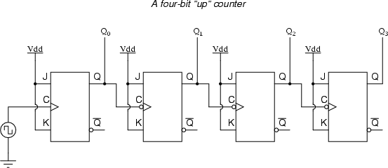

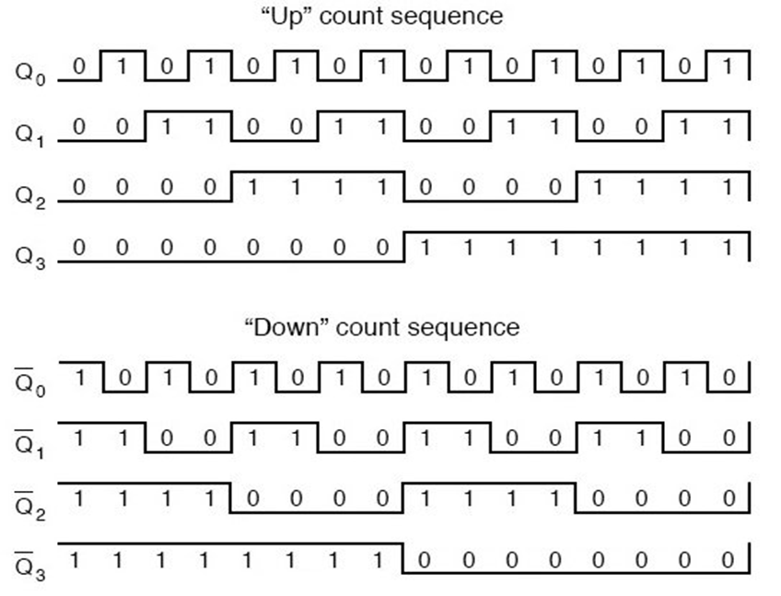

Timing diagram of Asynchronous Counter

**/*Asynchronous counter program Verilog code for design file name counter-4bit.v*/**

`timescale 1ns/1ps //Defining a Timescale for Precision

module counter(clk,rst,m,count); //Defining Module and Port List

input clk,rst,m; //Defining Inputs

output reg [3:0]count; //Defining 4-bit Output as Reg type

always@(posedge clk or negedge rst) //The Block is executed when either of positive edge of clock

begin // or negedge of rst arrives

if(!rst)

count=0; // Both are independent events

if(m) //i.e., Asynchronous Up counter

count=count+1;

else //i.e., Asynchronous Down counter

count=count-1;

end

endmodule

**/*Asynchronous counter program Verilog code for testbench-file name tb_counter-4bit.v*/**

`timescale 1ns/1ps //Creating Time Scale as in Source Code

module counter_test; //Defining Module Name without Port List

reg clk, rst,m; //Defining I/P as Registers [to Hold Values]

wire [3:0] count; //Defining O/P as Wires [To Probe Waveforms]

initial begin

clk=0; //Initializing Clock and Reset

rst=0;#25; //All O/P is 4’b0000 from t=0 to t=25ns.

rst=1; //Up-Down counting is allowed at posedge clk

end

initial begin

m=1; //Condition for Up-Count

#600 m=0; //Condition for Down-Count

rst=0;#25;

rst=1;

#500 m=0;

end

counter counter1(clk,m,rst, count); //Instantiation of Source Code

always #5 clk=~clk; //Inverting clk every 5ns

initial

#1400 $finish; //Finishing Simulation at t=1400ns

Endmodule

**Waveform:**

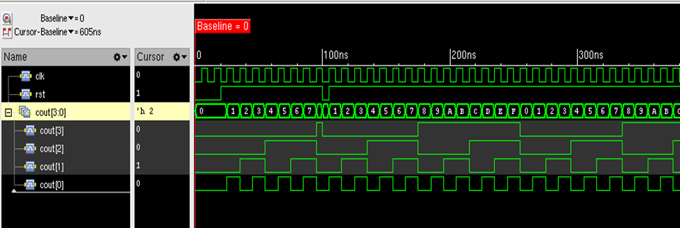

**b) Synthesize the design using Constraints and Analyze reports, critical path and Max Operating Frequency.**

**Step 1: Getting Started**

* Make sure you close out all the Incisive tool windows first.
* Synthesis requires three files as follows,

◦ Liberty Files (.lib)

◦ Verilog/VHDL Files (.v or .vhdl or .vhd)

◦ SDC (System Design Constraint) File (.sdc)

**Step 2 : Creating an SDC File**

* In your terminal type “gedit counter_top.sdc” to create an SDC File if you do not have one.
* The SDC File must contain the following commands;

i. create_clock -name clk -period 2 -waveform {0 1} [get_ports "clk"]

ii. set_clock_transition -rise 0.1 [get_clocks "clk"]

iii.set_clock_transition -fall 0.1 [get_clocks "clk"]

iv.set_clock_uncertainty 0.01 [get_ports "clk"]

v. set_input_delay -max 1.0 [get_ports "rst"] -clock [get_clocks "clk"]

vi.set_output_delay -max 1.0 [get_ports "count"] -clock [get_clocks "clk"]

i→ Creates a Clock named “clk” with Time Period 2ns and On Time from t=0 to t=1.

ii, iii → Sets Clock Rise and Fall time to 100ps.

iv → Sets Clock Uncertainty to 10ps.

v, vi → Sets the maximum limit for I/O port delay to 1ps.

**Step 3 : Performing Synthesis**

The Liberty files are present in the below path,

/home/install/FOUNDRY/digital/<Technology_Node_number>nm/dig/lib/

**Synthesis RTL Schematic**

**The procedure for Simulation and Synthesis remains same as mentioned earlier**

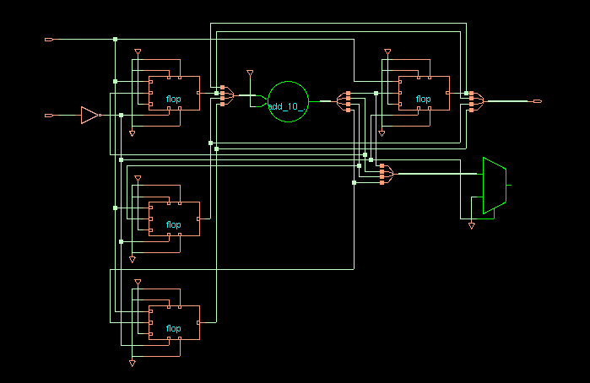

**PROGRAM:**

**/*32-bit up/down asynchronous reset counter Verilog code-file name counter.v*/**

`timescale 1ns/1ps // Defining a Timescale for Precision

module counter(clk,rst,m,count); // Defining Module and Port List

input clk,rst,m; // Defining Inputs

output reg [31:0]count; // Defining 4-bit Output as Reg type

always@(posedge clk or negedge rst) // The Block is executed when begin

// EITHER of positive edge of clock or Neg Edge of Rst arrives

if(!rst) // Both are independent events

count=0;

if(m)

count=count+1;

else count=count-1;

end

endmodule

/* **32-bit up/down asynchronous reset counter for testbench-file name tb_counter.v*/**

`timescale 1ns/1ps //Creating Time Scale as in Source Code

module counter_test; //Defining Module Name without Port List

reg clk, rst,m; //Defining I/P as Registers [to Hold Values]

wire [31:0] count; //Defining O/P as Wires [To Probe Waveforms] initial

begin

clk=0; //Initializing Clock and Reset

rst=0;#25; //All O/P is 4’b0000 from t=0 to t=25ns.

rst=1;

end //Up-Down counting is allowed at posedge clk

initial begin

m=1; //Condition for Up-Count

#600 m=0; rst=0;

#25; rst=1;

#500 m=0; //Condition for Down-Count

end

counter counter1(clk,m,rst, count); //Instantiation of Source Code always

#5 clk=~clk; //Inverting Clk every 5ns

initial

#1400 $finish; //Finishing Simulation at t=1400ns

endmodule

**Waveform:**

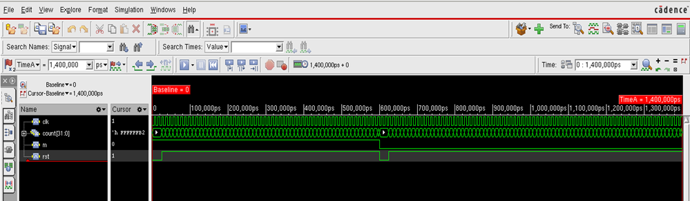

**Synthesis RTL Schematic:**

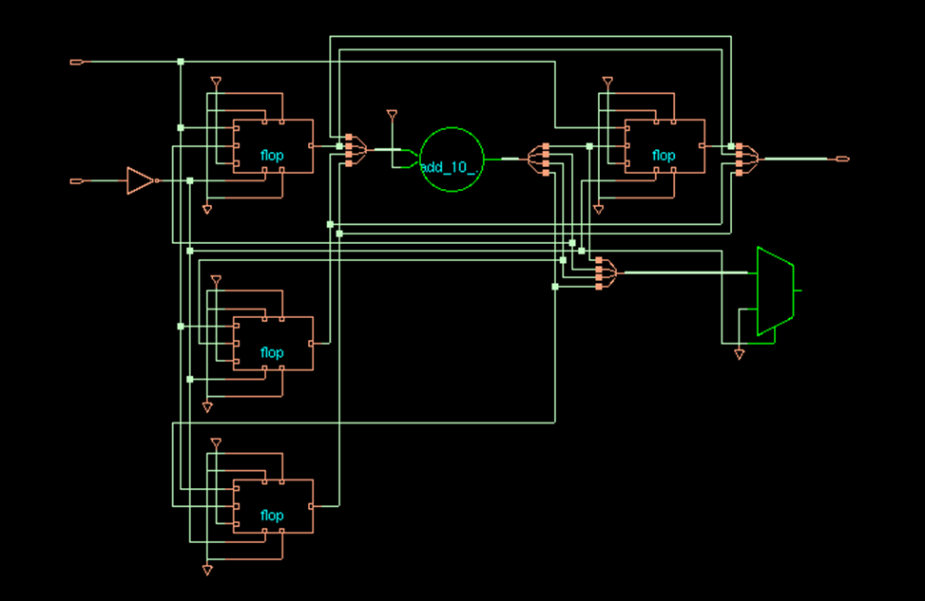

**RESULT:** Verilog code for an Asynchronous 4-bit Counter circuit and its test bench for verification is written, the waveform is observed and the code is synthesized with the technological library and is verified.

Experiment-2

Title: 4-bit Adder

**Problem Statement:** To develop the source code for 4-bit Adder by using VERILOG and obtain the simulation and its test bench for verification, observe the waveform, synthesize the code with technological library with given Constraints to generate into a netlist and place and route and implement it.

**Objectives:**

Write Verilog code for 4-bit Adder and verify its functionality using test bench.

Synthesize the design by setting proper constraints and obtain the net list.

From the report generated, identify critical path, maximum delay, total number of cells, power requirement and total area required. Change the constraints and obtain optimum synthesis results.

# TOOL REQUIRED: Cadence Tool

**THEORY:**

4-bit Adder is a combinatorial circuit (not clocked, does not have any memory and feedback) adding every bit position of the operands in the same time. Thus it is requiring number of bit-Adders (full adders + 1 half adder) equal to the number of bits to be added. The 4-bit adder is constructed by cascading full adders (FA) blocks in series. One full adder is responsible for the addition of two binary digits at any stage of the ripple carry. The carryout of one stage is fed directly to the carry-in of the next stage.

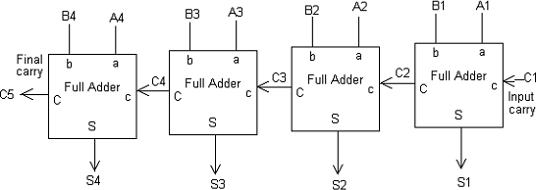

**PROGRAM:**

Three Codes are written for implementation of 4-bit Adder

◦ fa.v → Single Bit 3-input Full Adder [Sub-Module / Function]

◦ fa_4bit.v → Top Module for Adding 4-bit inputs

◦ fa_test.v → Test bench code for testing of 4-bit Adder design

**/* fa.v → Single Bit 3-input Full Adder */**

module full_adder( A,B,CIN,S,COUT);

input A,B,CIN;

output S,COUT;

assign S = A^B^CIN;

assign COUT = (A&B) | (CIN&(A^B));

endmodule

**/* fa_4bit.v → Top Module for Adding 4-bit Inputs */**

module four_bit_adder(A,B,C0,S,C4);

input [3:0] A,[3:0] B,C0;

output [3:0] S,C4;

wire C1,C2,C3;

full_adder fa0 (A[0],B[0],C0,S[0],C1);

full_adder fa1 (A[1],B[1],C1,S[1],C2);

full_adder fa2 (A[2],B[2],C2,S[2],C3);

full_adder fa3 (A[3],B[3],C3,S[3],C4);

endmodule

**/* Test Bench – fa_test.v */**

module test_4_bit;

reg [3:0] A;

reg [3:0] B; reg C0;

wire [3:0] S; wire C4;

four_bit_adder dut(A,B,C0,S,C4);

initial begin

A = 4'b0011;B=4'b0011;C0 = 1'b0; #10;

A = 4'b1011;B=4'b0111;C0 = 1'b1; #10;

A = 4'b1111;B=4'b1111;C0 = 1'b1; #10;

end

initial

#50 $finish;

Endmodule

**Waveform :**

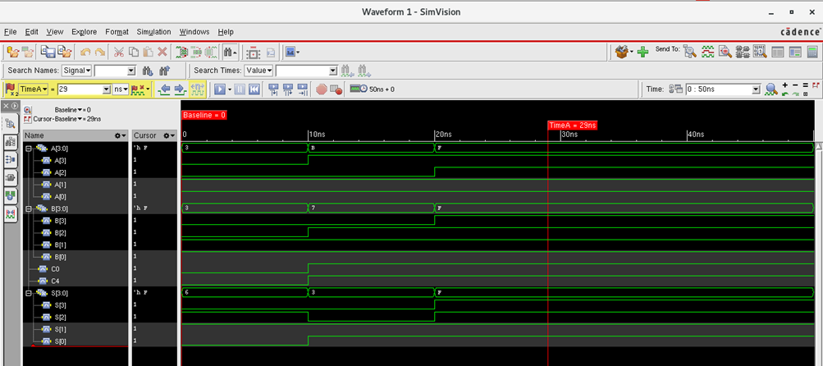

**b) Synthesis and Report/Output Analysis**

Step 1: Getting Started

* Make sure you close out all the Incisive tool windows first.
* Synthesis requires three files as follows,

◦ Liberty Files (.lib)

◦ Verilog/VHDL Files (.v or .vhdl or .vhd)

◦ SDC (System Design Constraint) File (.sdc)

Step 2 : Creating an SDC File

* As the Full Adder Program does not contain any Clock, SDC can be skipped as an Input if you wish to, else you could include only Area Constraints in form of commands during synthesis such as, set_dont_use *XL (Indicating not to use Larger Cells)

Step 3 : Performing Synthesis

* The Liberty files are present in the below path,
* /home/install/FOUNDRY/digital/<Technology_Node_number>nm/dig/lib/
* The Available technology nodes are 180nm ,90nm and 45nm. In the terminal, initialise the tools with the following commands if a new terminal is being used.

- csh

- source /home/install/cshrc

* The tool used for Synthesis is “Genus”. Hence, type “genus -gui” to open the tool.
* The Following are commands to proceed,

1. read_libs /home/install/FOUNDRY/digital/90nm/dig/lib/slow.lib

2. read_hdl {fa.v fa_4bit.v} //Reading multiple Verilog Files

3. elaborate

4. set_top_module four_bit_adder //Differentiating Top & Sub Module

5. set_dont_use *XL //Dont Use Cells with High Driving Strength

6. synthesize -to_mapped -effort medium //Performing Synthesis Mapping and Optimization

7. report_timing -unconstrained > counter_timing.rep

// Generates Timing report for worst datapath and dumps into file

//-Unconstrained is to be given as no timing constraints are given

8. report_area > counter_area.rep //Generates Synthesis Area report and dumps into a file

9. report_power > counter_power.rep

//Generates Power Report [Pre-Layout]

1. write_hdl > counter_netlist.v //Creates readable Netlist File.
2. write_sdc > counter_sdc.sdc //Creates Block Level SDC

Commands 1-5 are intended for Synthesis process while 6-10 for Generating reports and Outputs.

**Note 1:-**

1. The Cells given in the netlist can be checked in the .lib files for their properties.

2. The Max Operating Frequency does not apply for Purely Combinational Circuit.

**Synthesis RTL Schematic:**

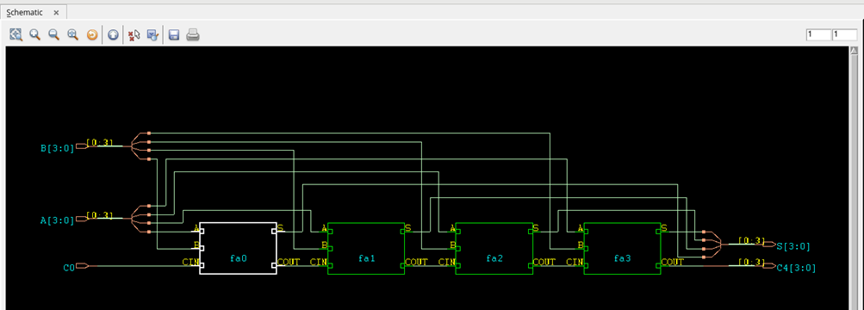

**Some Common Constraints are given below for**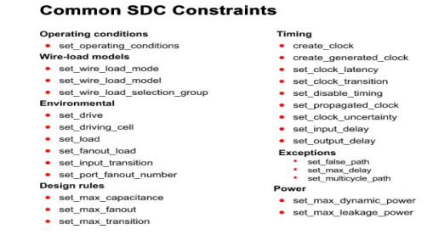

**Note-2:-**

1. Tabulate Area, Power and Timing Constraints using any of the SDC Constraints as instructed.

2. Make sure, during synthesis the Report File Names are changed so that the latest reports do not overwrite the earlier ones.

**RESULT:** Verilog code for the 4-bit Adder circuit and its test bench for verification is written, the waveform is observed and the code is synthesized with the technological library and is verified.

**Experiment No: 3**

**Title: UART**

**Problem statement:** To develop the source code for UART by using VERILOG and obtain the simulation and its test bench for verification, observe the waveform, synthesize the code with technological library with given Constraints to generate into a netlist and place and route and implement it.

**Objective:**

a) To Verify the Functionality using test Bench

b) Synthesize Design using constraints

c) Tabulate Reports using various Constraints

d) Identify Critical Path and calculate Max Operating Frequency

**Theory:**

UART (Universal Asynchronous Receiver and Transmitter) is a serial communication protocol. Basically this protocol is used to permit short distance, low cost and reliable full duplex communication. It is used to exchange data between the processor and peripherals. The UART has three main parts- receiver, transmitter and baud rate generator. Baud rate generator generates the clock frequency for transmitter and receiver at a specific baud rate. The UART design has used a baud rate of 115200 bps with 25 MHz Clock.

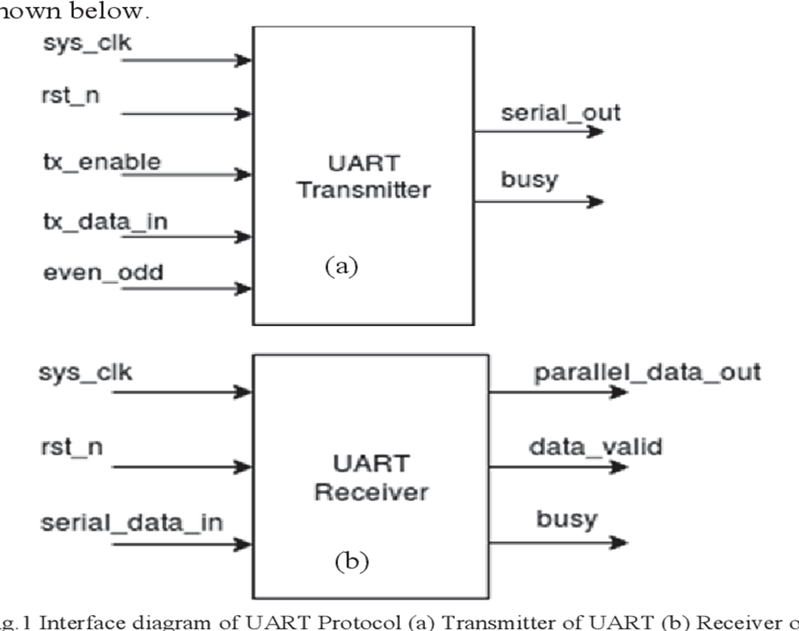

Creating a Workspace:

Create a new sub-Directory for the Design and open a terminal from the Sub-Directory.

**a)Functional Verification using Test Bench**

// Source code – Transmitter:

// This code contains the UART Transmitter. This transmitter is able to transmit 8 bits of serial data, one

// start bit, one stop bit, and no parity bit.

// When transmit is complete o_Tx_done will be driven high for one clock cycle.

//

// Set Parameter CLKS_PER_BIT as follows:

// CLKS_PER_BIT = (Frequency of i_Clock)/(Frequency of UART)

// Example: 25 MHz Clock, 115200 baud UART

// (25000000)/(115200) = 217

module uart_tx

  #(parameter CLKS_PER_BIT)

  (

   input       i_Clock,

   input       i_Tx_DV,

   input [7:0] i_Tx_Byte,

   output      o_Tx_Active,

   output reg  o_Tx_Serial,

   output      o_Tx_Done

   );

  parameter s_IDLE         = 3'b000;

  parameter s_TX_START_BIT = 3'b001;

  parameter s_TX_DATA_BITS = 3'b010;

  parameter s_TX_STOP_BIT  = 3'b011;

  parameter s_CLEANUP      = 3'b100;

  reg [2:0]    r_SM_Main     = 0;

  reg [7:0]    r_Clock_Count = 0;

  reg [2:0]    r_Bit_Index   = 0;

  reg [7:0]    r_Tx_Data     = 0;

  reg          r_Tx_Done     = 0;

  reg          r_Tx_Active   = 0;

  always @(posedge i_Clock)

    begin

      case (r_SM_Main)

        s_IDLE :

          begin

            o_Tx_Serial   <= 1'b1;         // Drive Line High for Idle

            r_Tx_Done     <= 1'b0;

            r_Clock_Count <= 0;

            r_Bit_Index   <= 0;

            if (i_Tx_DV == 1'b1)

              begin

                r_Tx_Active <= 1'b1;

                r_Tx_Data   <= i_Tx_Byte;

                r_SM_Main   <= s_TX_START_BIT;

              end

            else

              r_SM_Main <= s_IDLE;

          end // case: s_IDLE

        // Send out Start Bit. Start bit = 0

        s_TX_START_BIT :

          begin

            o_Tx_Serial <= 1'b0;

            // Wait CLKS_PER_BIT-1 clock cycles for start bit to finish

            if (r_Clock_Count < CLKS_PER_BIT-1)

              begin

                r_Clock_Count <= r_Clock_Count + 1;

                r_SM_Main     <= s_TX_START_BIT;

              end

            else

              begin

                r_Clock_Count <= 0;

                r_SM_Main     <= s_TX_DATA_BITS;

              end

          end // case: s_TX_START_BIT

        // Wait CLKS_PER_BIT-1 clock cycles for data bits to finish

        s_TX_DATA_BITS :

          begin

            o_Tx_Serial <= r_Tx_Data[r_Bit_Index];

            if (r_Clock_Count < CLKS_PER_BIT-1)

              begin

                r_Clock_Count <= r_Clock_Count + 1;

                r_SM_Main     <= s_TX_DATA_BITS;

              end

            else

              begin

                r_Clock_Count <= 0;

                // Check if we have sent out all bits

                if (r_Bit_Index < 7)

                  begin

                    r_Bit_Index <= r_Bit_Index + 1;

                    r_SM_Main   <= s_TX_DATA_BITS;

                  end

                else

                  begin

                    r_Bit_Index <= 0;

                    r_SM_Main   <= s_TX_STOP_BIT;

                  end

              end

          end // case: s_TX_DATA_BITS

        // Send out Stop bit.  Stop bit = 1

        s_TX_STOP_BIT :

          begin

            o_Tx_Serial <= 1'b1;

            // Wait CLKS_PER_BIT-1 clock cycles for Stop bit to finish

            if (r_Clock_Count < CLKS_PER_BIT-1)

              begin

                r_Clock_Count <= r_Clock_Count + 1;

                r_SM_Main     <= s_TX_STOP_BIT;

              end

            else

              begin

                r_Tx_Done     <= 1'b1;

                r_Clock_Count <= 0;

                r_SM_Main     <= s_CLEANUP;

                r_Tx_Active   <= 1'b0;

              end

          end // case: s_Tx_STOP_BIT

        // Stay here 1 clock

        s_CLEANUP :

          begin

            r_Tx_Done <= 1'b1;

            r_SM_Main <= s_IDLE;

          end

        default :

          r_SM_Main <= s_IDLE;

      endcase

    end

  assign o_Tx_Active = r_Tx_Active;

  assign o_Tx_Done   = r_Tx_Done;

endmodule// Source code – Receiver :

// This file contains the UART Receiver. This receiver is able to receive 8 bits of serial data, one start bit,

// one stop bit, and no parity bit. When receive is complete o_rx_dv will be driven high for one clock cycle.

// Set Parameter CLKS_PER_BIT as follows:

// CLKS_PER_BIT = (Frequency of i_Clock)/(Frequency of UART)

// Example: 25 MHz Clock, 115200 baud UART

// (25000000)/(115200) = 217

|  | module uart_rx    #(parameter CLKS_PER_BIT)    (     input        i_Clock,     input        i_Rx_Serial,     output       o_Rx_DV,     output [7:0] o_Rx_Byte     );    parameter s_IDLE         = 3'b000;    parameter s_RX_START_BIT = 3'b001;    parameter s_RX_DATA_BITS = 3'b010;    parameter s_RX_STOP_BIT  = 3'b011;    parameter s_CLEANUP      = 3'b100;      reg           r_Rx_Data_R = 1'b1;    reg           r_Rx_Data   = 1'b1;      reg [7:0]     r_Clock_Count = 0;    reg [2:0]     r_Bit_Index   = 0; //8 bits total    reg [7:0]     r_Rx_Byte     = 0;    reg           r_Rx_DV       = 0;    reg [2:0]     r_SM_Main     = 0;      // Purpose: Double-register the incoming data.    // This allows it to be used in the UART RX Clock Domain.    // (It removes problems caused by metastability)    always @(posedge i_Clock)      begin        r_Rx_Data_R <= i_Rx_Serial;        r_Rx_Data   <= r_Rx_Data_R;      end        // Purpose: Control RX state machine    always @(posedge i_Clock)      begin          case (r_SM_Main)          s_IDLE :            begin              r_Rx_DV       <= 1'b0;              r_Clock_Count <= 0;              r_Bit_Index   <= 0;                if (r_Rx_Data == 1'b0)          // Start bit detected                r_SM_Main <= s_RX_START_BIT;              else                r_SM_Main <= s_IDLE;            end            // Check middle of start bit to make sure it's still low          s_RX_START_BIT :            begin              if (r_Clock_Count == (CLKS_PER_BIT-1)/2)                begin                  if (r_Rx_Data == 1'b0)                    begin                      r_Clock_Count <= 0;  // reset counter, found the middle                      r_SM_Main     <= s_RX_DATA_BITS;                    end                  else                    r_SM_Main <= s_IDLE;                end              else                begin                  r_Clock_Count <= r_Clock_Count + 1;                  r_SM_Main     <= s_RX_START_BIT;                end            end // case: s_RX_START_BIT              // Wait CLKS_PER_BIT-1 clock cycles to sample serial data          s_RX_DATA_BITS :            begin              if (r_Clock_Count < CLKS_PER_BIT-1)                begin                  r_Clock_Count <= r_Clock_Count + 1;                  r_SM_Main     <= s_RX_DATA_BITS;                end              else                begin                  r_Clock_Count          <= 0;                  r_Rx_Byte[r_Bit_Index] <= r_Rx_Data;                    // Check if we have received all bits                  if (r_Bit_Index < 7)                    begin                      r_Bit_Index <= r_Bit_Index + 1;                      r_SM_Main   <= s_RX_DATA_BITS;                    end                  else                    begin                      r_Bit_Index <= 0;                      r_SM_Main   <= s_RX_STOP_BIT;                    end                end            end // case: s_RX_DATA_BITS              // Receive Stop bit.  Stop bit = 1          s_RX_STOP_BIT :            begin              // Wait CLKS_PER_BIT-1 clock cycles for Stop bit to finish              if (r_Clock_Count < CLKS_PER_BIT-1)                begin                  r_Clock_Count <= r_Clock_Count + 1;                  r_SM_Main     <= s_RX_STOP_BIT;                end              else                begin                  r_Rx_DV       <= 1'b1;                  r_Clock_Count <= 0;                  r_SM_Main     <= s_CLEANUP;                end            end // case: s_RX_STOP_BIT              // Stay here 1 clock          s_CLEANUP :            begin              r_SM_Main <= s_IDLE;              r_Rx_DV   <= 1'b0;            end              default :            r_SM_Main <= s_IDLE;          endcase      end      assign o_Rx_DV   = r_Rx_DV;    assign o_Rx_Byte = r_Rx_Byte;    endmodule // uart_rx |
| --- | --- |

**Test bench:**

// This testbench will exercise the UART RX.

// It sends out byte 0x37, and ensures the RX receives it correctly.

`timescale 1ns/10ps

`include "uart_tx.v"

`include "uart_rx.v"

module UART_TB();

// Testbench uses a 25 MHz clock

// Want to interface to 115200 baud UART

// 25000000 / 115200 = 217 Clocks Per Bit.

parameter c_CLOCK_PERIOD_NS = 40;

parameter c_CLKS_PER_BIT= 217;

parameter c_BIT_PERIOD = 8600;

reg r_Clock = 0; reg r_TX_DV = 0;

wire w_TX_Active, w_UART_Line;

wire w_TX_Serial;

reg [7:0] r_TX_Byte = 0;

wire [7:0] w_RX_Byte;

UART_RX #(.CLKS_PER_BIT(c_CLKS_PER_BIT)) UART_RX_Inst

(.i_Clock(r_Clock),

.i_RX_Serial(w_UART_Line),

.o_RX_DV(w_RX_DV),

.o_RX_Byte(w_RX_Byte)

);

UART_TX #(.CLKS_PER_BIT(c_CLKS_PER_BIT)) UART_TX_Inst

(.i_Clock(r_Clock),

.i_TX_DV(r_TX_DV),

.i_TX_Byte(r_TX_Byte),

.o_TX_Active(w_TX_Active),

.o_TX_Serial(w_TX_Serial),

.o_TX_Done()

);

// Keeps the UART Receive input high (default) when UART transmitter is not active

assign w_UART_Line = w_TX_Active ? w_TX_Serial : 1'b1;

always

#(c_CLOCK_PERIOD_NS/2) r_Clock <= !r_Clock;

// Main Testing:

Initial begin

// Tell UART to send a command (exercise TX) @(posedge r_Clock);

@(posedge r_Clock); r_TX_DV <= 1'b1;

r_TX_Byte <= 8'h3F; @(posedge r_Clock); r_TX_DV <= 1'b0;

end

endmodule

**Waveform:**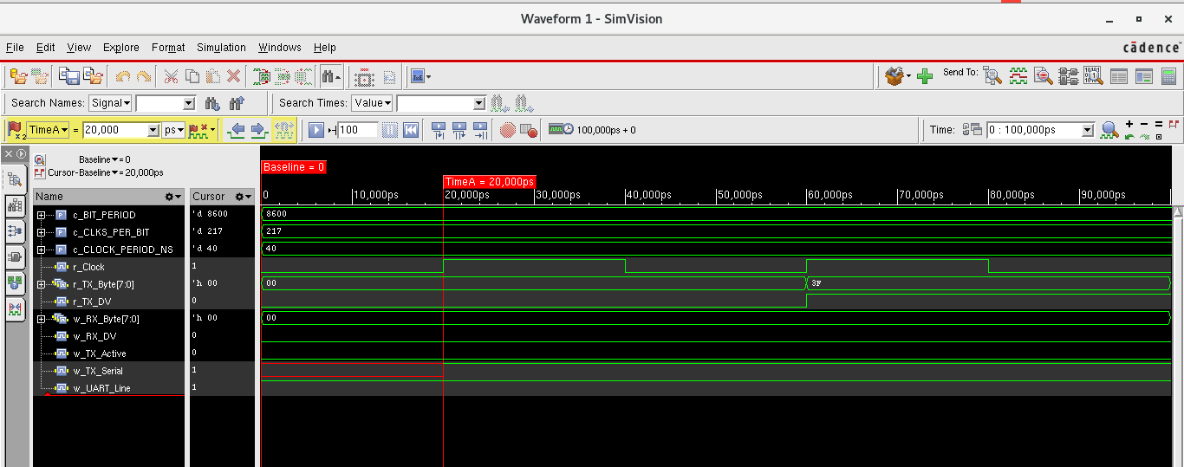

**b) Synthesize the Design**

1. read_libs /home/install/FOUNDRY/digital/90nm/dig/lib/slow.lib

2. read_hdl {uart_tx.v / uart_rx.v} //Choose any one

3. elaborate

4. read_sdc constraints_top.sdc //Reading Top Level SDC

5. synthesize -to_mapped -effort medium //Performing Synthesis Mapping and Optimization

6. report_timing > uart_timing.rep

//Generates Timing report for worst datapath and dumps into file

7. report_area > uart_area.rep //Generates Synthesis Area report and dumps into a file

8. report_power > uart_power.rep //Generates Power Report [Pre-Layout]

9. write_hdl > uart_netlist.v //Creates readable Netlist File

10. write_sdc > uart_sdc.sdc //Creates Block Level SDC

**Synthesis RTL Schematic:**

**Constraints file for Synthesis:**

create_clock -name clk -period 10 -waveform {0 5} [get_ports "clk"]

set_clock_transition -rise 0.1 [get_clocks "clk"]

set_clock_transition -fall 0.1 [get_clocks "clk"]

set_clock_uncertainty 1.0 [get_ports "clk"]

set_input_delay -max 1.0 [get_ports "rst"] -clock [get_clocks "clk"]

set_input_delay -max 1.0 [get_ports "din"] -clock [get_clocks "clk"]

set_output_delay -max 1.0 [get_ports "q"] -clock [get_clocks "clk"]

set_output_delay -max 1.0 [get_ports "qb"] -clock [get_clocks "clk"]

**Synthesis RTL Schematic:** 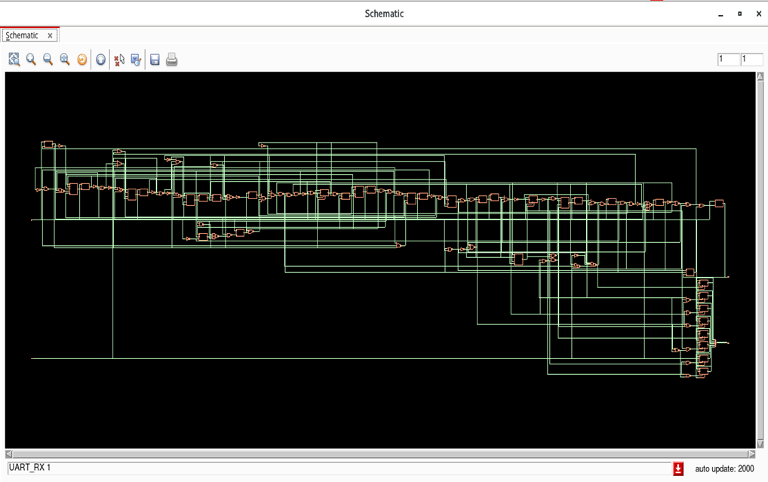

**Note:-**

1. Tabulate Area, Power and Timing Constraints using any of the SDC Constraints as instructed.

2. Make sure, during synthesis the Report File Names are changed so that the latest reports do not overwrite the earlier ones.

**RESULT:** Verilog code for the UART circuit and its test bench for verification is written, the waveform is observed and the code is synthesized with the technological library with given constraints and is verified.

**Experiment-4**

**Title: 32-bit ALU**

**Problem statement:** To develop the source code for 32-bit ALU by using VERILOG and obtain the simulation and its test bench for verification, observe the waveform, synthesize the code with technological library with given Constraints to generate into a netlist, place and route and implement it.

**Objectives:**

a) To Verify the Functionality using Test Bench

b) Synthesize and compare the results using if and case statements

c) Identify Critical Path and constraints

**Creating a Work space:**

Create a new sub-Directory for the Design and open a terminal from the Sub-Directory.

**Theory:**

An Arithmetic Logic Unit (ALU) is a digital circuit used to perform arithmetic and logic operations. It represents the fundamental building block of the central processing unit (CPU) of a computer. Most of the operations of a CPU are performed by one or more ALUs, which load data from input registers.

A 32-bit ALU is a combinational circuit taking two 32-bit data words A and B as inputs, and producing a 32-bit output Y by performing a specified arithmetic or logical function on the A and B inputs.

Arithmetic Logic Unit (ALU) using these simple logic gates AND, OR, NOT, XOR and other components. The ALU will take in two 32-bit values, and two control lines. Depending on the value of the control lines, the output will be the addition, subtraction, bitwise AND or bitwise OR of the inputs. The Fig. 1 shows the block diagram of 32-bit ALU.

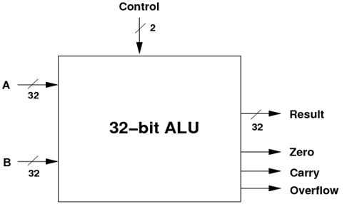

**Fig-1: 32-bit ALU**

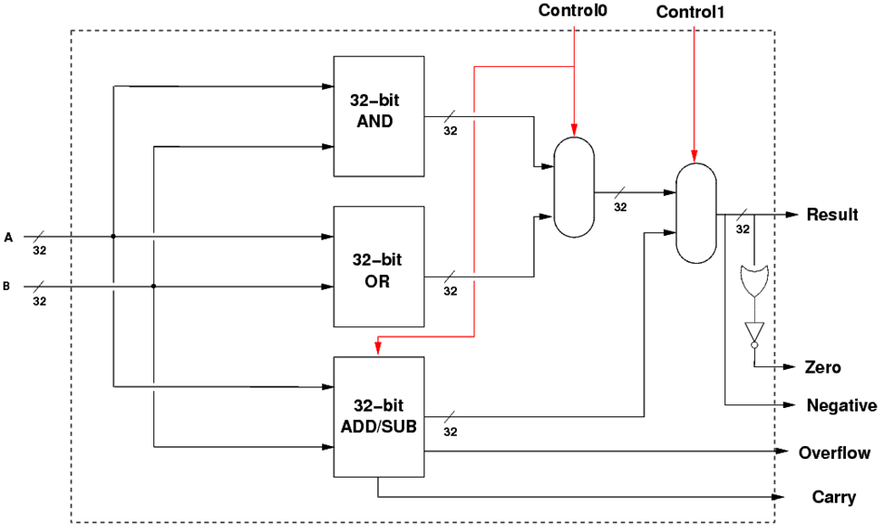

Fig-2: Logic Diagram of 32-bit ALU

**Basic components:**

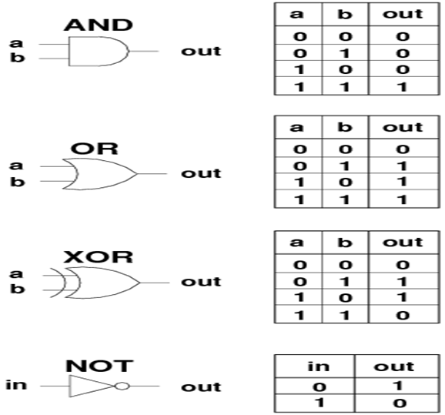

**a)To Verify the Functionality using Test Bench**

**Source Code – Using Case Statement:**

module alu_32bit_case(y,a,b,f);

input [31:0]a;

input [31:0]b;

input [2:0]f;

output reg [31:0]y;

always@(*)

begin

case(f)

3'b000:y=a&b; //AND Operation

3'b001:y=a|b; //OR Operation

3'b010:y=~(a&b); //NAND Operation

3'b011:y=~(a|b); //NOR Operation

3'b010:y=a+b; //Addition

3'b011:y=a-b; //Subtraction

3'b100:y=a*b; //Multiply

default:y=32'bx;

endcase

end

endmodule

**Test Bench:**

module alu_32bit_tb_case;

reg [31:0]a;

reg [31:0]b;

reg [2:0]f;

wire [31:0]y;

alu_32bit_case test2(.y(y),.a(a),.b(b),.f(f));

initial begin

a=32'h00000000; b=32'hFFFFFFFF;

#10 f=3'b000;

#10 f=3'b001;

#10 f=3'b010;

#10 f=3'b100;

end

initial

#50 $finish;

endmodule

**B:Source Code - Using If Statement:**

module alu_32bit_if(y,a,b,f);

input [31:0]a;

input [31:0]b;

input [2:0]f; output reg [31:0]y;

always@(*)

begin   
if(f==3'b000)

y=a&b; //AND Operation else if (f==3'b001)

y=a|b; //OR Operation else if (f==3'b010)

y=a+b; /Addition else if (f==3'b011)

y=a-b; /Subtraction else if (f==3'b100)

y=a*b; //Multiply else

y=32'bx;

end

endmodule

**Test bench:**

module alu_32bit_tb_if;

reg [31:0]a;

reg [31:0]b;

reg [2:0]f;

wire [31:0]y;

alu_32bit_if test(.y(y),.a(a),.b(b),.f(f));

initial begin

a=32'h00000000;

b=32'hFFFFFFFF; #10 f=3'b000;

#10 f=3'b001;

#10 f=3'b010;

#10 f=3'b100;

end initial

#50 $finish;

endmodule

**Waveforms:**

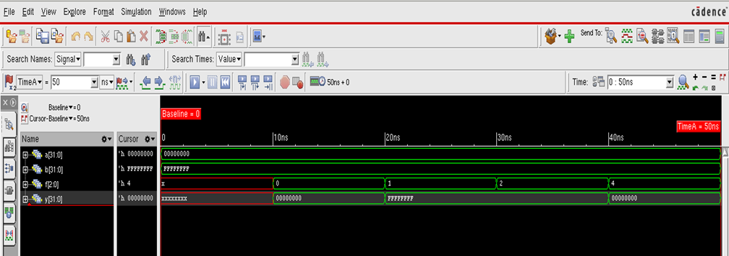

**b) Synthesize Design**

•Run the synthesis Process one time for each code and make sure the output File names are changed accordingly.

**Synthesis Process:**

1. read_libs /home/install/FOUNDRY/digital/90nm/dig/lib/slow.lib

2. read_hdl {alu_32bit_if.v (OR) alu_32bit_case.v} //Choose any one

3. elaborate

4. read_sdc constraints_top.sdc //Optional-Reading Top Level SDC

5. synthesize -to_mapped -effort medium //Performing Synthesis Mapping and Optimization

6. report_timing > alu_timing.rep //Generates Timing report for worst datapath and dumps into file

7. report_area > alu_area.rep //Generates Synthesis Area report and dumps into a file

8. report_power > uart_power.rep //Generates Power Report [Pre-Layout]

9. write_hdl > uart_netlist.v //Creates readable Netlist File

10. write_sdc > uart_sdc.sdc //Creates Block Level SDC

#### RTL Schematic of 32-bit Floating Point ALU with Pipelining

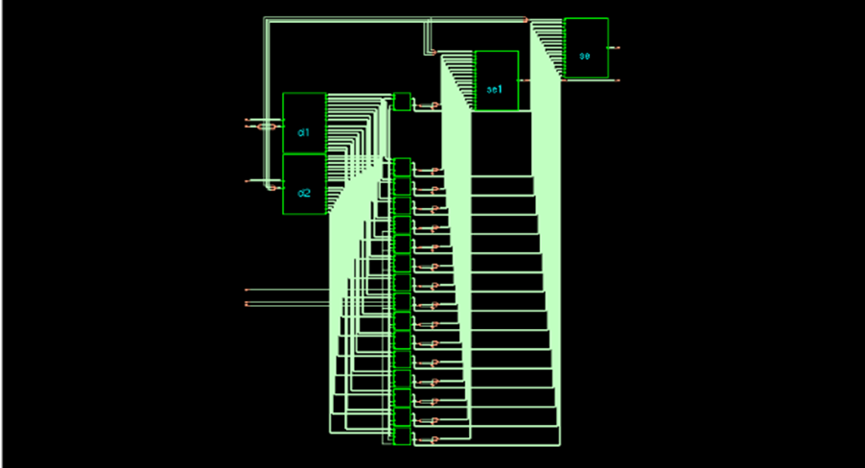

**Note:-**

1. Tabulate Area, Power and Timing Constraints using any of the SDC Constraints as instructed.

2. Make sure, during synthesis the Report File Names are changed so that the latest reports do not overwrite the earlier ones.

**RESULT:** Verilog code for the 32-bit ALU circuit and its test bench for verification is written, the waveform is observed and the code is synthesized with the technological library and given constraints and is verified.

**Experiment No: 5**

**Title: Latches and Flip Flops**

Problem Statement: Write verilog code for D, SR, JK Latch and Flip-flop, Synthesize the design and compare the synthesis report.

Objectives:

1. Write Verilog code for D, SR, JK Latch
2. Write Verilog code for D, SR, JK Flip Flop
3. Synthesize the designs

5a. i) D flipflop

**Theory:**

D flip-flop The D flip-flop is widely used. It is also known as a "data" flip-flop. The D flip-flop captures the value of the D-input at a definite portion of the clock cycle (such as the rising edge of the clock). That captured value becomes the Q output. At other times, the output Q does not change. The D flip-flop can be viewed as a memory cell, a zero-order hold, or a delay line.

**Block diagram:**

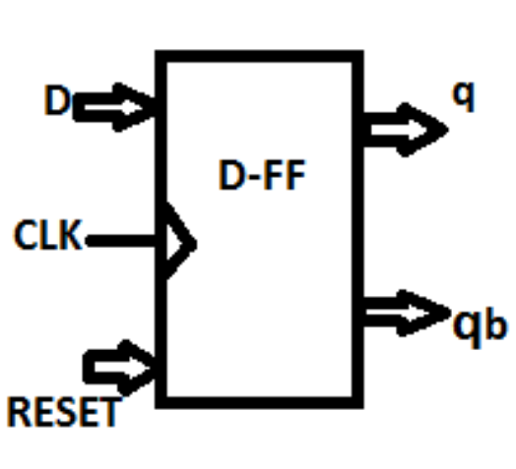

**Truth Table:**

| Reset | Clock | D | Q | Qb |
| --- | --- | --- | --- | --- |
| 0 |  | 1 | 1 | 0 |
| 0 |  | 0 | 0 | 1 |
| 0 | 0 | X | X | Hold |
| 1 |  | X | 0 | 1 |

**Design Equation/ calculations (if any):**

Q(t+1) = D(t)

**Verilog Code with Comments:**

`timescale 1ns / 10ps

module DFF( Q,Qbar,D,Clk,Reset);

output reg Q;

output Qbar;

input D,Clk,Reset;

always @(posedge Clk)

begin

if (Reset == 1'b1) //If at reset

Q <= 1'b0;

else

Q <= D;

end

assign Qbar = ~Q;

endmodule

**Test bench code:**

`timescale 1ns / 10ps

module DFF_tb;

reg D, Clk, Reset; // Inputs

wire Q, Qbar; // Outputs

// Instantiate the Unit Under Test (UUT)

DFF uut ( .Q(Q), .Qbar(Qbar), .D(D), .Clk(Clk), .Reset(Reset));

initial begin

D = 1'b0; // Initialize Inputs

Clk = 1'b0;

Reset = 1'b1;

// Wait 100 ns for global reset to finish

#100;

// Add stimulus here

Reset = 1'b0;

#20;

forever #40 D = ~ D;

end

always #10 Clk = ~Clk;

endmodule

**Simulation output:**

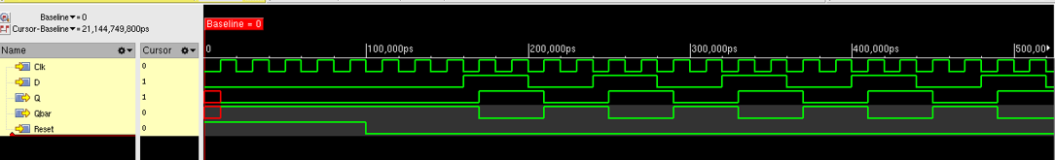

**Constraint File:**

create_clock -name clk -period 2 -waveform {0 1} [get_ports "clk"]

set_clock_transition -rise 0.1 [get_clocks "clk"]

set_clock_transition -fall 0.1 [get_clocks "clk"]

set_clock_transition -

set_clock_uncertainty 0.01 [get_clocks "clk"]

set_input_delay -max 1 [get_ports "Reset"] -clock [get_clocks "clk"]

set_input_delay -max 1 [get_ports "D"] -clock [get_clocks "clk"]

set_output_delay -max 1 [get_ports "Q"] -clock [get_clocks "clk"]

set_output_delay -max 1 [get_ports "Qbar"] -clock [get_clocks "clk"]

**Synthesis:**

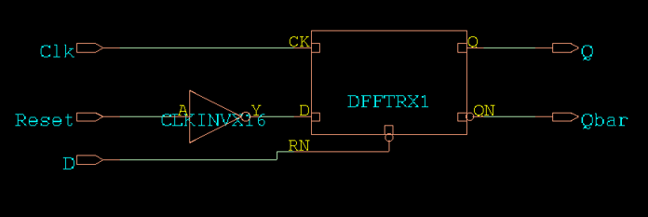

Gatelevel netlist, gate, area, timing, power reports are generated and analysed by the students

**Expected Outcomes:**

The students will be able to

* Write the Verilog code and analyze it with various testcases for the given input and output
* Analyse the reports generated with different input clock frequency

**Additional Experimental Questions:**

**Given the test inputs as given in the figure below and verify the outputs**

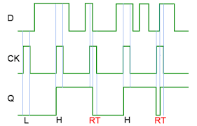

**Change the following constraints and analysis the timing, power, area and gate reports**

* **Clock inputs as 2ns, 4ns, 0.5ns in the constraint file and analyze the result and reports**

**Change the rising time and falling time to max of 0.5 and 1.5ns both at the input and /or output and analyze the result and reports**

**5a ii) S R Flip Flop**

**Theory:**

It can be seen that when both inputs S = “1” and R = “1” the outputs Q and Q can be at either logic level “1” or “0”, depending upon the state of the inputs S or R BEFORE this input condition existed. Therefore the condition of S = R = “1” does not change the state of the outputs Q and Q. However, the input state of S = “0” and R = “0” is an undesirable or invalid condition and must be avoided. The condition of S = R = “0” causes both outputs Q and Q to be HIGH together at logic level “1” when we would normally want Q to be the inverse of Q. The result is that the flip-flop loses control of Q and Q, and if the two inputs are now switched “HIGH” again after this condition to logic “1”, the flip-flop becomes unstable and switches to an unknown data state based upon the unbalance.

**Logic diagram:**

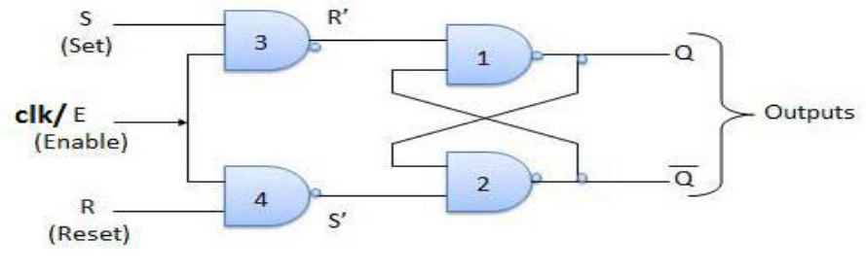

**Truth Table:**

| Clock | R | S | Q | Qb | Comments |
| --- | --- | --- | --- | --- | --- |
|  | 0 | 0 | Hold | | No change |
|  | 0 | 1 | 1 | 0 | Set |
| 0 | 1 | 0 | 0 | 1 | Reset |
|  | 1 | 1 | z | z | Indeterminate |
| 0 | X | X | Hold | | No change |

**Design Equation/ calculations (if any):**

Q(t+1) = R'(t)Q(t) + S(t) ; S(t)R(t) = 0

**Verilog Code with Comments**:

`timescale 1ns / 10ps

module SR_FF(S,R,clk,Q,Qbar);

input S,R,clk;

output Q,Qbar;

reg M,N;

always @(posedge clk)

begin

M = !(S & clk);

N = !(R & clk);

end

assign Q = !(M & Qbar);

assign Qbar = !(N & Q);

endmodule

**Test bench code:**

`timescale 1ns / 10ps

module SRFF_tb;

reg S, R; reg clk;

// Outputs

wire Q, Qbar;

// Instantiate the Unit Under Test (UUT)

SR_FF uut ( .S(S), .R(R), .clk(clk), .Q(Q), .Qbar(Qbar) );

initial begin

// Initialize Inputs

clk = 1'b0;

S =1'b0;

R=1'b0;

// Wait 100 ns for global reset to finish

#10;

// Add stimulus here

S =1'b1;R=1'b0;

#20 S =1'b0; R=1'b1;

#10 S =1'b0; R=1'b0;

#30 S =1'b1; R=1'b1;

#200 $finish;

end

always #10 clk = ~clk;

endmodule

**Simulation output:**

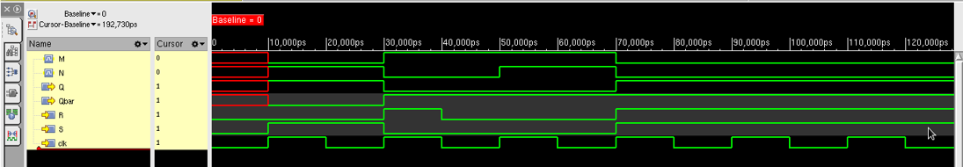

**Constraint File:**

create_clock -name clk -period 2 -waveform {0 1} [get_ports "clk"]

set_clock_transition -rise 0.1 [get_clocks "clk"]

set_clock_transition -fall 0.1 [get_clocks "clk"]

set_clock_transition -

set_clock_uncertainty 0.01 [get_clocks "clk"]

set_input_delay -max 1 [get_ports "S"] -clock [get_clocks "clk"]

set_input_delay -max 1 [get_ports "R"] -clock [get_clocks "clk"]

set_output_delay -max 1 [get_ports "Q"] -clock [get_clocks "clk"]

set_output_delay -max 1 [get_ports "Qbar"] -clock [get_clocks "clk"]

**Synthesis:**

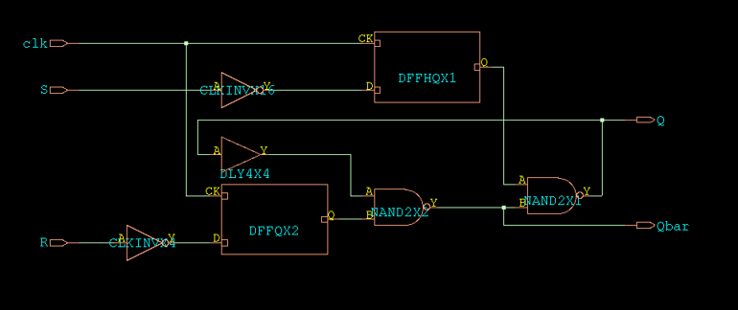

Gatelevel netlist, gate, area, timing, power reports are generated and analysed by the students

**Expected Outcomes:**

The students will be able to

* Write the Verilog code and analyze it with various testcases for the given input and output
* Analyse the reports generated with different input clock frequency

**Additional Experimental Questions:**

**Given the test inputs as given in the figure below and verify the outputs**

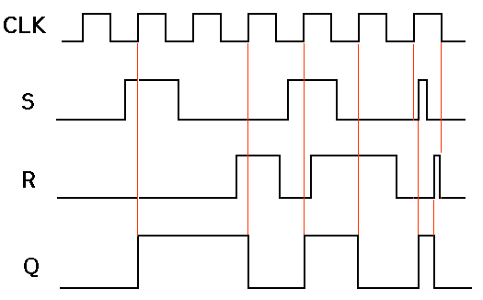

**Change the following constraints and analysis the timing, power, area and gate reports**

* **Clock inputs as 2ns, 4ns, 0.5ns in the constraint file and analyze the result and reports**
* **Change the rising time and falling time to max of 0.5 and 1.5ns both at the input and /or output and analyze the result and reports**

**5a iii) JK Flip Flop**

**Theory:**

Then the JK flip-flop is basically an SR flip-flop with feedback which enables only one of its two input terminals, either SET or RESET to be active at any one time thereby eliminating the invalid condition seen previously in the SR flip-flop circuit. Also when both the J and the K inputs are at logic level “1” at the same time, and the clock input is pulsed either “HIGH”, the circuit will “toggle” from its SET state to a RESET state, or visa-versa. This result in the JK flip-flop acting more like a T-type toggle flip-flop when both terminals are “HIGH”

Although this circuit is an improvement on the clocked SR flip-flop it still suffers from timing problems called “race” if the output Q changes state before the timing pulse of the clock input has time to go “OFF”. To avoid this the timing pulse period ( T ) must be kept as short as possible (high frequency). As this is sometimes not possible with modern TTL IC’s the much improved MasterSlave JK Flip-flop was developed

**Block and Logic diagram**:

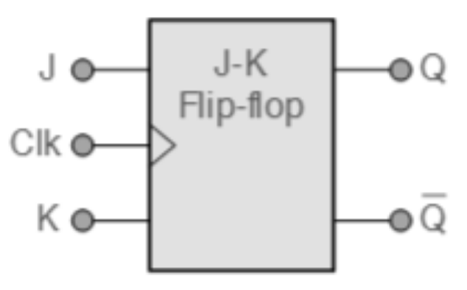 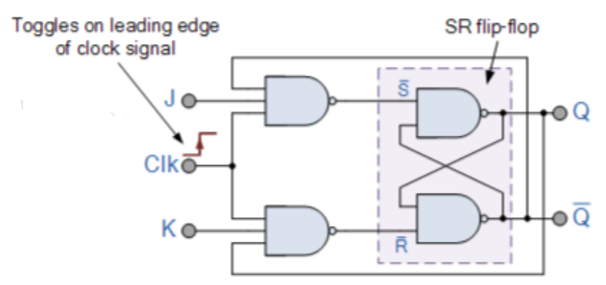

**Truth Table:**

| Clock | J | K | Q | Qm | Comments |
| --- | --- | --- | --- | --- | --- |
|  | 0 | 0 | Hold | | No change |
|  | 0 | 1 | 1 | 0 | Set |
| 0 | 1 | 0 | 0 | 1 | Reset |
|  | 1 | 1 | 0 | 1 | Toggle |
| 1 | 0 |
| 0 | X | X | Hold | | No change |

**Design Equation/ calculations (if any):**

**Q(t+1) = K'(t)Q(t) + J(t)Q'(t)**

**Verilog Code with Comments:**

`timescale 1ns / 10ps

module jkff(J, K, clk, Q, Qm);

input J, K, clk;

output reg Q;

output Qm;

always @(posedge clk)

begin

if(J == 0 && K == 0)

Q <= 0;

else if(J == 1 && K == 0)

Q <= 1;

else if(J == 0 && K == 1)

Q <= 0;

else if(J == 1 && K == 1)

Q <= ~Q;

end

assign Qm = ~Q;

endmodule

**Test bench code:**

`timescale 1ns / 10ps

module JKFF_tb;

// Inputs

reg J, K,,clk;

// Outputs

wire Q, Qm;

// Instantiate the Unit Under Test (UUT)

jkff uut ( .J(J), .K(K), .clk(clk), .Q(Q), .Qm(Qm) );

initial begin

// Initialize Inputs

clk = 1'b0;

J =1'b0;

K=1'b0;

// Wait 100 ns for global reset to finish

#10;

// Add stimulus here

J =1'b1; K=1'b0;

#20 J =1'b1; K=1'b1;

#10 J =1'b1; K=1'b0;

#30 J =1'b1; K=1'b1;

#30 J =1'b0; K=1'b0;

#200 $finish;

end

always #10 clk = ~clk;

endmodule

**Simulation output:**

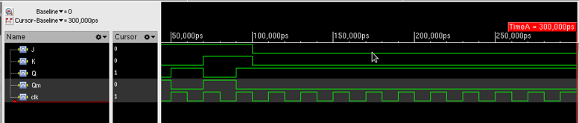

**Constraint File:**

create_clock -name clk -period 2 -waveform {0 1} [get_ports "clk"]

set_clock_transition -rise 0.1 [get_clocks "clk"]

set_clock_transition -fall 0.1 [get_clocks "clk"]

set_clock_transition -

set_clock_uncertainty 0.01 [get_clocks "clk"]

set_input_delay -max 1 [get_ports "J"] -clock [get_clocks "clk"]

set_input_delay -max 1 [get_ports "K"] -clock [get_clocks "clk"]

set_output_delay -max 1 [get_ports "Q"] -clock [get_clocks "clk"]

set_output_delay -max 1 [get_ports "Qm"] -clock [get_clocks "clk"]

**Synthesis:**

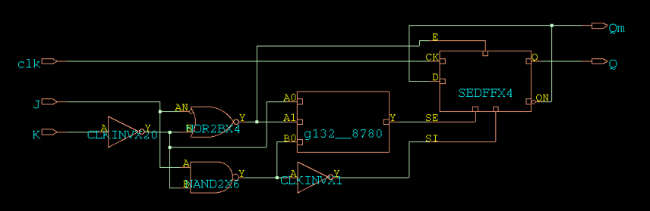

Gatelevel netlist, gate, area, timing, power reports are generated and analysed by the students

**Expected Outcomes:**

The students will be able to

* Write the Verilog code and analyze it with various testcases for the given input and output
* Analyse the reports generated with different input clock frequency

**Additional Experimental Questions:**

**Given the test inputs as given in the figure below and verify the outputs**

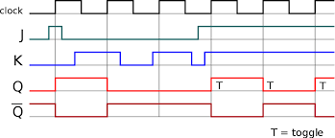

**Change the following constraints and analysis the timing, power, area and gate reports**

* **Clock inputs as 2ns, 4ns, 0.5ns in the constraint file and analyze the result and reports**
* **Change the rising time and falling time to max of 0.5 and 1.5ns both at the input and /or output and analyze the result and reports**

**5b i) D Latch**

**Theory:**

The **Gated D Latch** is another special type of gated latch having two inputs, i.e., DATA and ENABLE. When the enable input set to 1, the input is the same as the Data input. Otherwise, there is no change in output.

We can design the gated D latch by using gated SR latch. The set and reset inputs are connected together using an inverter. By doing this, the outputs will be opposite to each other. Below is the circuit diagram of the Gated D latch**.**

**Logic diagram:**

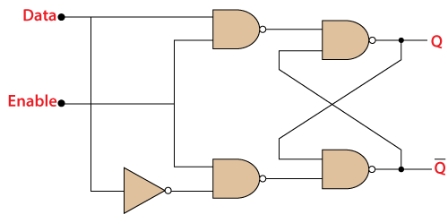

**Truth Table:**

| Enable(en) | D | Q | Qbar |
| --- | --- | --- | --- |
| 0 | 0 | Latch | latch |
| 0 | 1 | Latch | latch |
| 1 | 0 | 0 | 1 |
| 1 | 1 | 1 | 0 |

**Verilog Code with Comments:**

`timescale 1ns/10ps

module DFF( Q,Qbar,D,en,Reset);

output reg Q;

output Qbar;

input D,en,Reset;

always @ (en or Reset or D)

if (!Reset)

Q <= 0;

else

if (en)

Q <= D;

assign Qbar = ~Q;

endmodule

**Test bench code:**

`timescale 1ns / 10ps

module DFF_tb;

reg D, en, Reset; // Inputs

wire Q, Qbar; // Outputs

// Instantiate the Unit Under Test (UUT)

DFF uut ( .Q(Q), .Qbar(Qbar), .D(D), .en(en), .Reset(Reset) );

initial begin

D = 1'b0; // Initialize Inputs

en =1'b1;

Reset = 1'b1;

#50; // Wait 100 ns for global reset to finish

// Add stimulus here

Reset =1'b0;

#10 D=1'b1;

#20 Reset =1'b1;

#50 en =1'b0;

#10 D=1'b0;

#10 D=1'b1;

#10 D=1'b1;

#50 en =1'b1;

#20 D=1'b1;

#10 D=1'b0;

#20 D=1'b1;

#10 D=1'b0;

#50 D=1'b1;

#400 $finish;

end

endmodule

**Simulation output:**

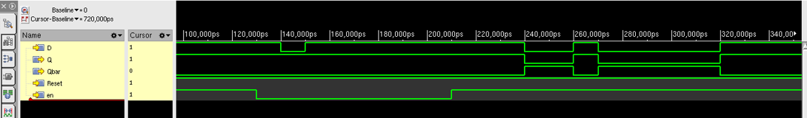

**Constraint File:**

set_input_delay -max 1 [get_ports "D"]

set_input_delay -max 1 [get_ports "en"]

set_output_delay -max 1 [get_ports "Q"]

set_output_delay -max 1 [get_ports "Qbar"]

**Synthesis:**

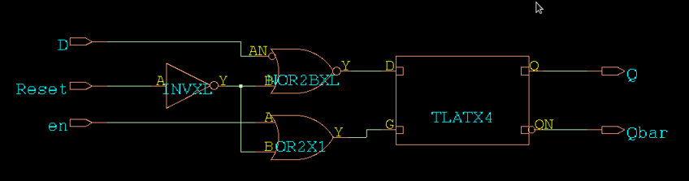

Gatelevel netlist, gate, area, timing, power reports are generated and analysed by the students

**Expected Outcomes:**

The students will be able to

* Write the Verilog code and analyze it with various testcases for the given input and output
* Analyse the reports generated with different input clock frequency

**Note: Additional variations that can be done from this experiment**

**(Eg: for flip flops given the waveform, write the test bench and obtained the given output**

**Possible change of values in the constraint file and analyze the result and reports)**

**5b ii) SR Latch**

**Theory:**

A **Gated SR Latch** is a special type of **SR Latch** having three inputs, i.e., Set, Reset, and Enable. The enable input must be active for the SET and RESET inputs to be effective. The **ENABLE** input of gated SR Latch enables the operation of the SET and RESET inputs. This **ENABLE** input connects with a switch. The Set-Reset inputs are enabled when this switch is on. Otherwise, all the changes are ignored in the set and reset inputs. Below are the circuit diagram and the truth table of the Gated SR latch.

**Logic diagram:** //using NOR gate

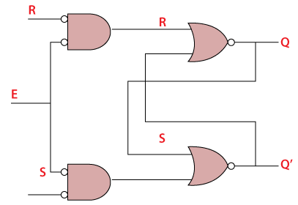

**Truth Table:**

| Enable(en) | S | R | Q | Qm |
| --- | --- | --- | --- | --- |
| 1 | 0 | 0 | Latch | Latch |
| 1 | 0 | 1 | 0 | 1 |
| 1 | 1 | 0 | 1 | 0 |
| 1 | 1 | 1 | 0 | 0 |
| 0 | X | X | Latch | |

**Verilog Code with Comments:**

`timescale 1ns / 10ps

module SRLatch (S,R,en,Q,Qm);

input S,R,en;

output Q,Qm;

reg M,N;

always @(en)

begin

M <= !(S & en);

N <= !(R & en);

end

assign Q = !(M & Qm);

assign Qm = !(N & Q);

endmodule

**Test bench code:**

`timescale 1ns / 10ps

module SRlatch_tb;

reg S, R, en; // Inputs

wire Q, Qm; // Outputs

// Instantiate the Unit Under Test (UUT)

SRLatch uut (.S(S), .R(R), .en(en), .Q(Q), .Qm(Qm));

initial begin

S = 1'b0; // Initialize Inputs

R = 1'b0;

en =1'b1;

#50; // Wait 100 ns for global reset to finish

// Add stimulus here

#10 S=1'b1; R=1'b0;

#100 en =1'b0;

#50 S=1'b0; R=1'b0;

#50 S=1'b1; R=1'b0;

#50 en =1'b1;

#100 S=1'b0; R=1'b1;

#150 S=1'b0; R=1'b0;

#100 S=1'b1; R=1'b0;

#150 S=1'b1; R=1'b1;

#50 S=1'b0; R=1'b0;

#200 S=1'b0;R=1'b0;

#600 $finish;

end

endmodule

**Simulation output:**

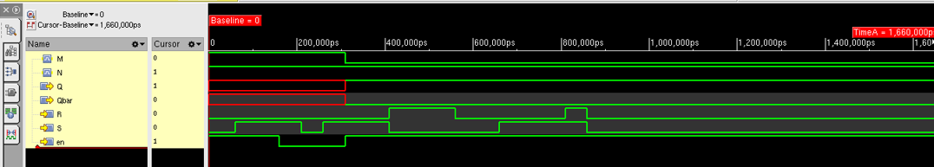

**Constraint File:**

set_input_delay -max 1 [get_ports "R"]

set_input_delay -max 1 [get_ports "en"]

set_input_delay -max 1 [get_ports "S"]

set_output_delay -max 1 [get_ports "Q"]

set_output_delay -max 1 [get_ports "Qbar"]

**Synthesis:**

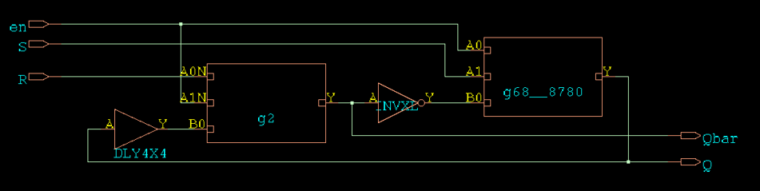

Gatelevel netlist, gate, area, timing, power reports are generated and analysed by the students

**Expected Outcomes:**

The students will be able to

* Write the Verilog code and analyze it with various testcases for the given input and output
* Analyse the reports generated with different input clock frequency

**Note: Additional variations that can be done from this experiment**

**(Eg: for flip flops given the waveform, write the test bench and obtained the given output**

**Possible change of values in the constraint file and analyze the result and reports)**

**5b iii) JK Latch**

**Theory:**

The **JK Latch** is the same as the **SR Latch**. In JK latch, the unclear states are removed, and the output is toggled when the JK inputs are high. The only difference between SR latch JK latches is that there is no output feedback towards the inputs in the SR latch, but it is present in the JK latch. The circuit diagram and truth table of the JK latch are as follows:

**Logic diagram:**

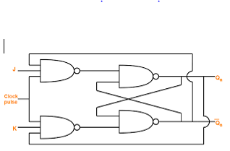

**Truth Table**:

| Enable | J | K | Q | Qm | Comments |
| --- | --- | --- | --- | --- | --- |
| 1 | 0 | 0 | Q | Q | No change |
| 1 | 0 | 1 | 1 | 0 | Set |
| 1 | 1 | 0 | 0 | 1 | Reset |
| 1 | 1 | 1 | Qb | Q | Toggle |
| 0 | X | X | Latch | | No change |

**Verilog Code with Comments:**

`timescale 1ns / 10ps

module JKLatch(J, K, en, Q,Qm);

input J, K, en;

output reg Q;

output Qm;

always @(en)

begin

if(J == 0 && K == 0)

Q <= Q;

else if(J == 1 && K == 0)

Q <= 1;

else if(J == 0 && K == 1)

Q <= 0;

else if(J == 1 && K == 1)

Q <= ~Q;

end

assign Qm=~Q;

endmodule

**Test bench code:**

`timescale 1ns / 10ps

module JKlatch_tb;

reg J, K, en; // Inputs

wire Q, Qm; // Outputs

// Instantiate the Unit Under Test (UUT)

JKLatch uut (.J(J), .K(K), .en(en), .Q(Q), .Qm(Qm));

initial begin

J = 1'b0; // Initialize Inputs

K = 1'b0;

en =1'b1;

#50; // Wait 100 ns for global reset to finish

// Add stimulus here

#10 J=1'b1; K=1'b0;

#100 en =1'b0;

#50 J=1'b0; K=1'b0;

#50 J=1'b1; K=1'b0;

#50 en =1'b1;

#100 J=1'b0; K=1'b1;

#150 J=1'b0; K=1'b0;

#100 J=1'b1; K=1'b0;

#150 J=1'b1; K=1'b1;

#50 J=1'b0; K=1'b0;

#200 J=1'b0; K=1'b0;

#600 $finish;

end

endmodule

**Simulation output:**

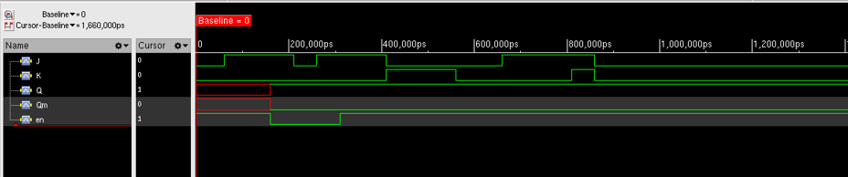

**Constraint File:**

set_input_delay -max 1 [get_ports "J"]

set_input_delay -max 1 [get_ports "K"]

set_input_delay -max 1 [get_ports "en"]

set_output_delay -max 1 [get_ports "Q"]

set_output_delay -max 1 [get_ports "Qm"]

**Synthesis:**

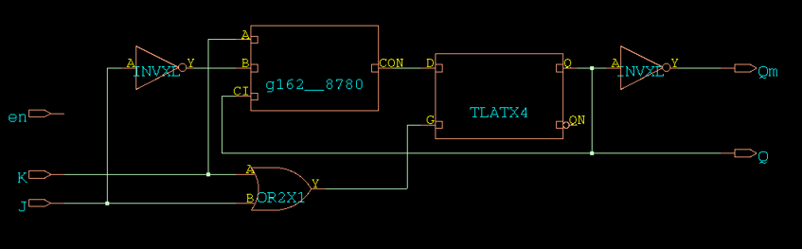

Gatelevel netlist, gate, area, timing, power reports are generated and analysed by the students

**Expected Outcomes:**

The students will be able to

* Write the Verilog code and analyze it with various testcases for the given input and output
* Analyse the reports generated with different input clock frequency

**Experiment No: 6**

**Title: Physical Design**

**Problem statement:** To develop the Physical Design (Floor planning, Placement, Routing in Layout of any two experiments of 1 to 5

**Objective:**

**For the synthesized netlist carry out the following for any two above experiments:**

a. Floor planning (automatic), identify the placement of pads

b. Placement and Routing, record the parameters

c. Physical verification and record the LVS and DRC reports

d. Perform Back annotation and verify the functionality of the design

e. Generate GDSII and record the number of masks and its color composition

**Mandatory inputs for PD:**

1. Gate Level Netlist [Output of Synthesis]
2. Block Level SDC [Output of Synthesis]
3. Liberty Files (.lib)
4. LEF Files (Layer Exchange Format)

**Expected Outputs from PD:**

1. GDS II File (Graphical Data Stream for Information Interchange – Feed In for Fabrication Unit).

* Make sure the Synthesis for the target design is done and open a terminal from the corresponding workspace.
* Initiate the Cadence tools enters into Innovus command prompt where in the tool commands can be entered.

**Physical Design involves 5 stages as following:**

After Importing Design,

→ Floor Planning

→ Power Planning

→ Placement

→ CTS (Clock Tree Synthesis)

→ Routing

**Importing Design**

To Import Design, all the Mandatory Inputs are to be loaded and this can be done either using script files named with .globals and .view/.tcl or through GUI as shown below.

**The target design considered here is 4-bit counter.**

**The procedure shall remain the same for any other design from the above discussed experiments.**

**Note:**

1. For Synthesis, slow.lib was read as input. Each liberty file contains a pre-defined Process, Voltage and

Temperature (PVT) values which impact the ease of charge movement.

1. Process, Voltage and Temperature individually affect the ease of currents as depicted below.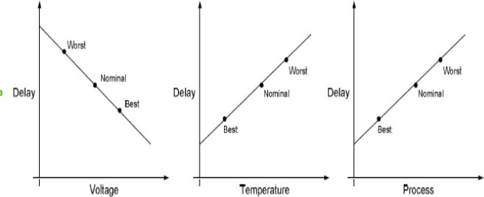

3. Hence, slow.lib contains PVT combination (corner) with **slow** charge movement => **Maximum** Delay => **Worst** Performance

4. Similarly, fast.lib contains PVT Combination applicable across its designs to give **Fast** charge movement => **Minimum** Delay => **Best** Performance.

5. When these corners are collaborated with the **sdc**, they can be used to analyze timing for setup in the worst case and hold in the best case.

6. All these analysis views are to be manually created either in the form of script or using the GUI.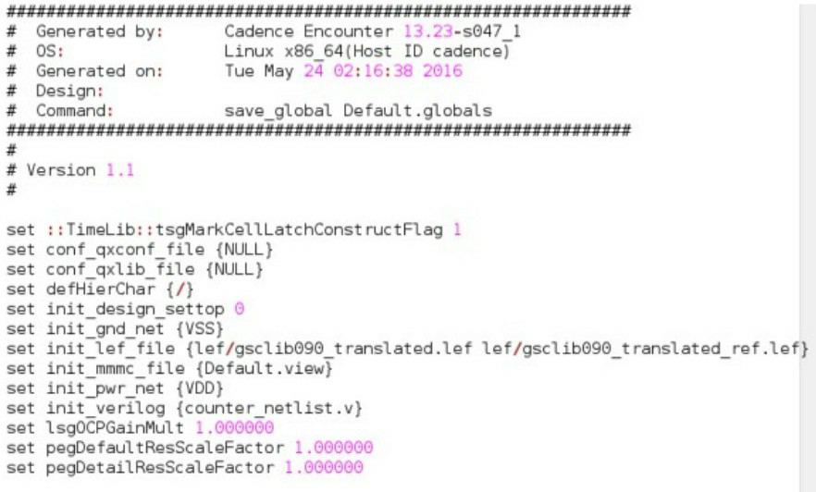

Script under Default. Globals file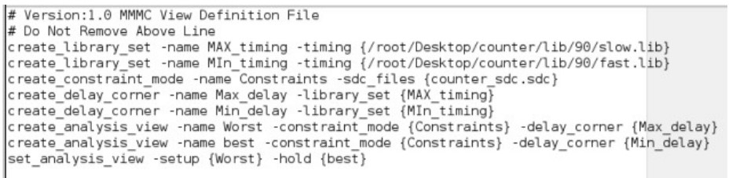

Script under Default.view (or) Default.tcl file

**Note:** Check the paths to properly read in the input files.

* Else, if you would like to import your design using GUI, open the Innovus tool and from the GUI, go to File → Import Design.
* A new pop-up window appears.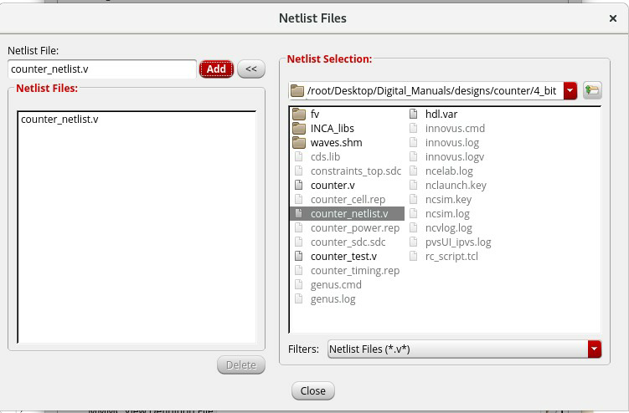
* First load the netlist. You can browse for the file and select “Top cell : Auto Assign”.

Similarly select your lef files from /home/install/FOUNDRY/digital/90nm/ dig/lef/ as shown below.

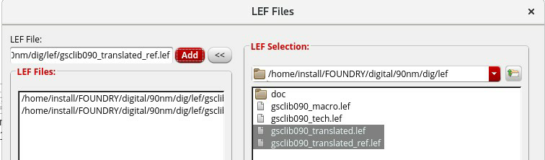

Once both the Netlist and LEF Files are load ed, your import design window is as follows.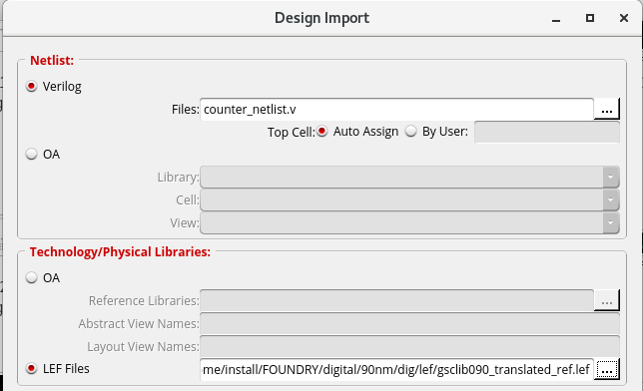

* In order to load the Liberty File and SDC, create delay corners and analysis view, select the “Create Analysis Configuration” option at the bottom.

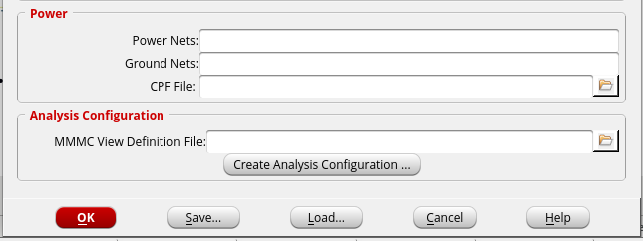

* An MMMC browser Pops Up.

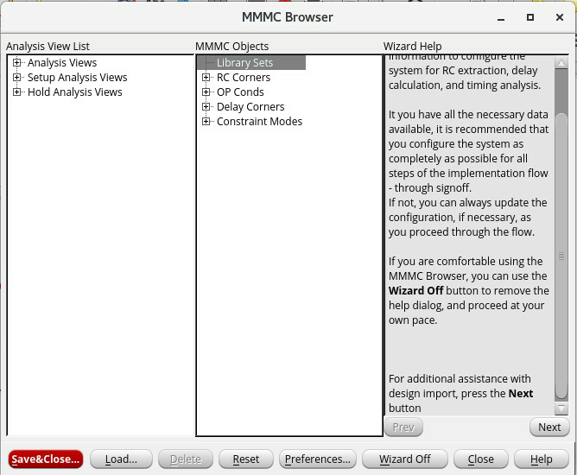

The order of adding the MMMC Objects is as follows.

1. Library Sets
2. RC Corners
3. Delay Corners
4. Constraints (SDC)

Once all of them are added, Analysis Views are created and assigned to Setup and Hold.

In order to add any of the objects, make a right click on the corresponding label → Select New.

Adding Liberty Files under “Library Sets”

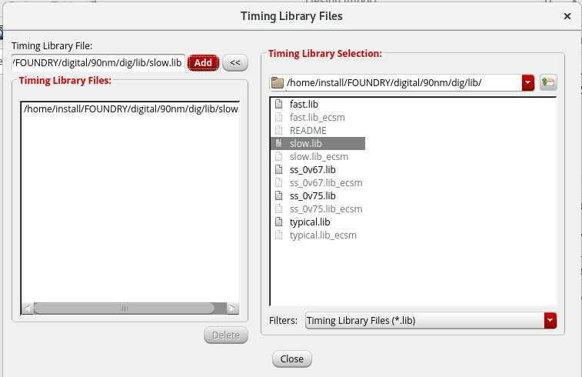

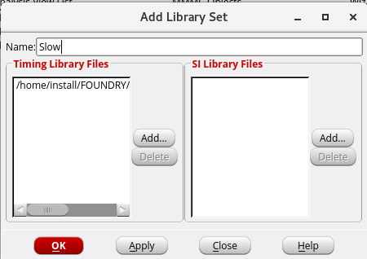

* + Similarly, add fast.lib with a label Fast or any identifier of your own.
* AAdding RC Corners can also be done in a similar process. The temperature value can be found under the corresponding liberty file. Also, cap table and RC Tech files can be added from Foundry where available.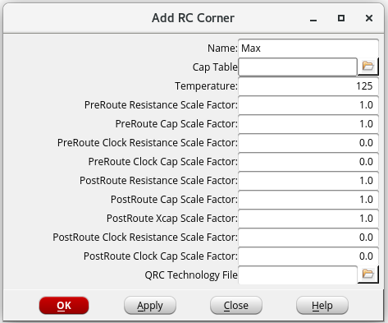

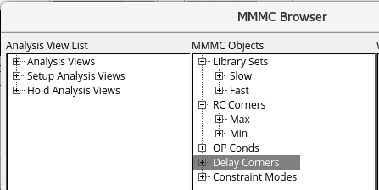

* Delay Corners are formed by combining Library Sets with RC Corners.
* An example is shown below.

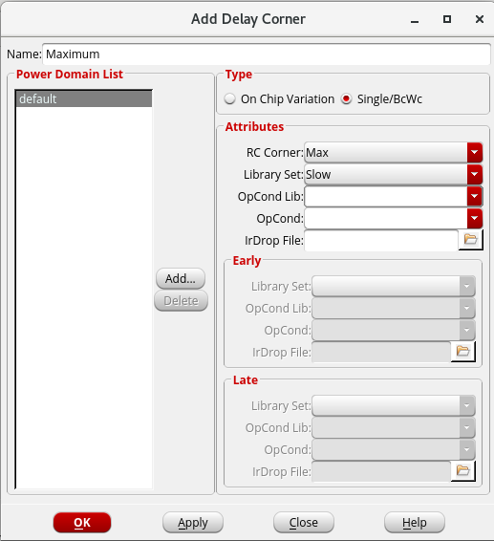

* Similarly, SDC can be read in under the MMMC Object of “Constraints”.

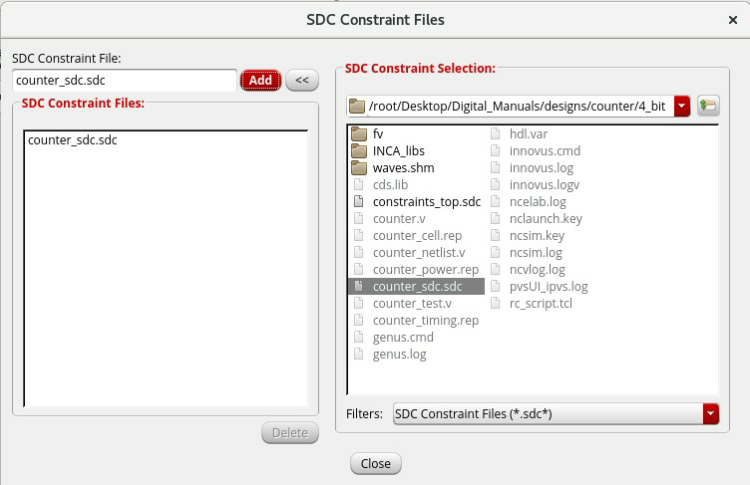

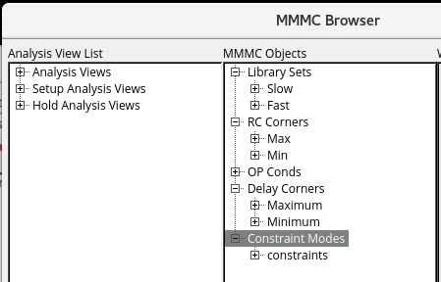

* + Analysis Views are formed from combinations of SDC and Delay Corner.

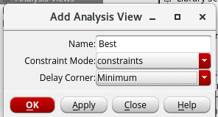

* Once “Best” and “Worst” Analysis views are created, assign them to Setup and Hold.

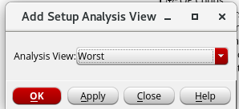

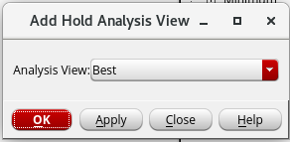

Once all the process is done, Click on “Save&Close” and save the script generated with any name of your choice.

* Make sure the file extension remains .view or .tcl
* After saving the script, go back to Import Design window and Click “OK” to load your design.

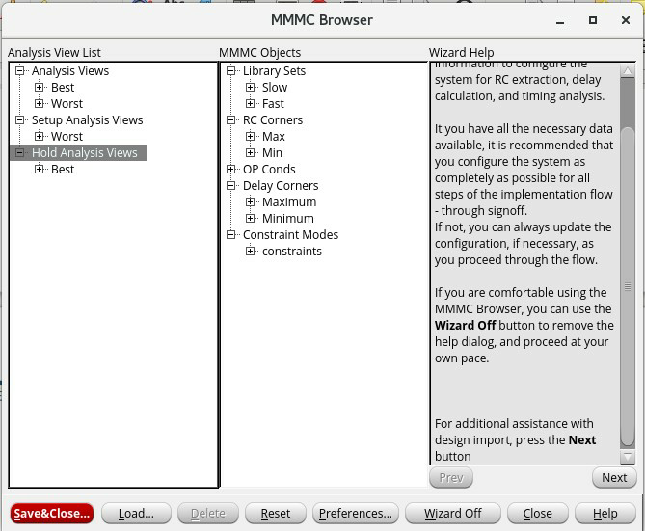

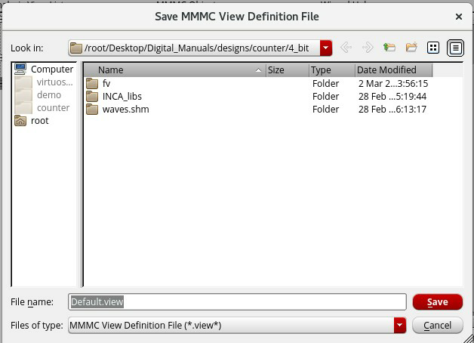

* Add Power and Ground Net names (Identifiers) under Import design window.

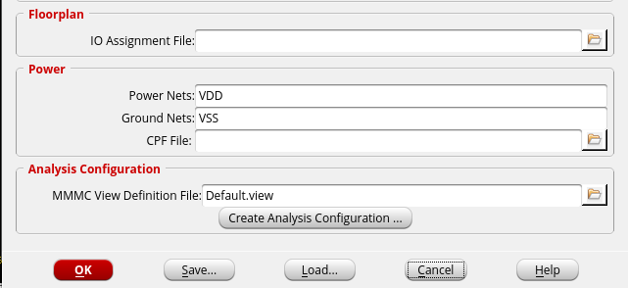

* A rectangular or square box appears in your GUI if and only if all the inputs are read properly.

If the box does not appear, check for errors in your log (Either on terminal or log file from pwd)

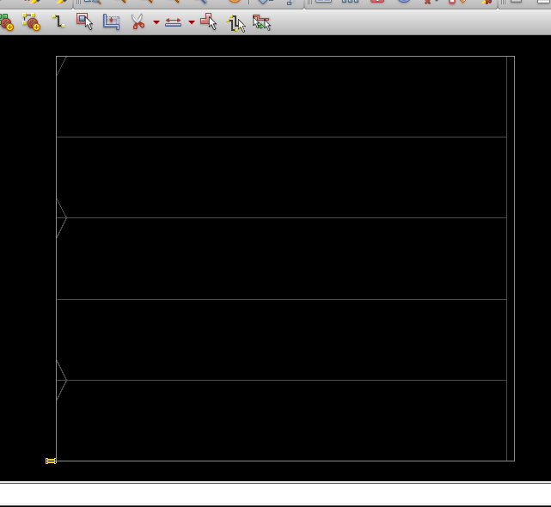

* The internal area of the box is called “Core Area”.
* The horizontal lines running along the width of Core are “Standard Cell Rows”. Every alternate of them are marked indicating alternate VDD and VSS rows.
* This setup is called “**Flipped Standard Cell Rows**”.

→ **Floorplan**

Steps under Floorplan :

1. Aspect Ratio [Ratio of Vertical Height to Horizontal Width of Core]
2. Core Utilisation [The total Core Area % to be used for Floor Planning]
3. Channel Spacing between Core Boundary to IO Boundary
   * Select Floorplan → Specify Floorplan to modify/add concerned values to the above Factors. On adding/modifying the concerned values, the core area is also modified.

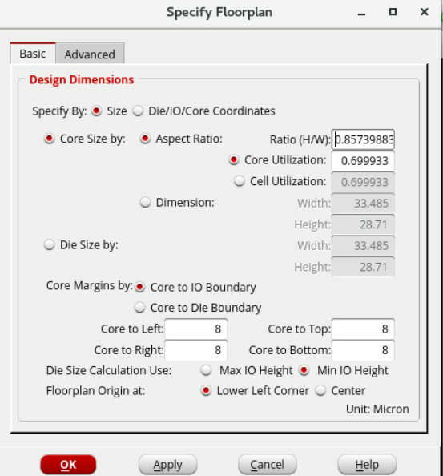

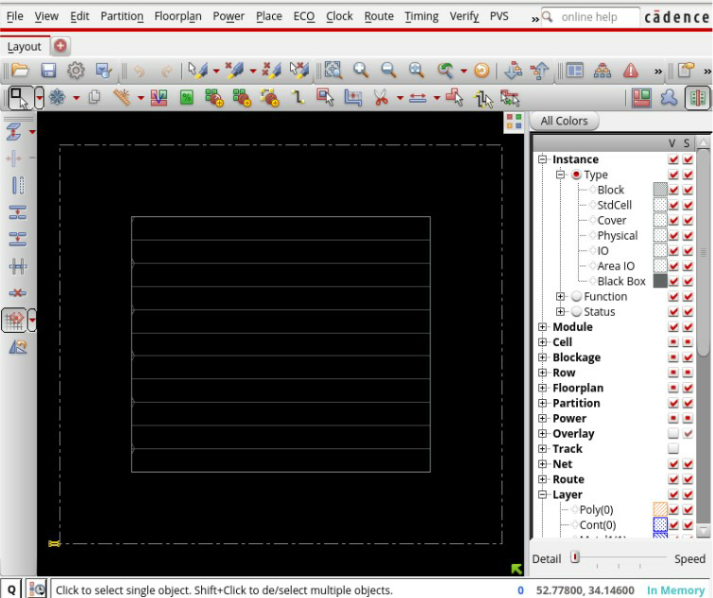

* The Yellow patch on the Left Bottom are the group of “Unassigned pins” which are to be placed along the IO Boundary along with the Standard Cells [Gates].

→ **Power Planning**

Steps under Power Planning :

1. Connect Global Net Connects
2. Adding Power Rings
3. Adding Power Strings
4. Special Route

Under Connect Global Net Connects, we create two pins, one for VDD and one for VSS connecting them to corresponding Global Nets as mentioned in Globals file / Power and Ground Nets.

1. Select Power → Connect Global Nets.. to create “Pin” and “Connect to Global Net” as shown and use “Add to list”.
2. Click on “Apply” to direct the tool in enforcing the Pins and Net connects to Design and then Close the window.

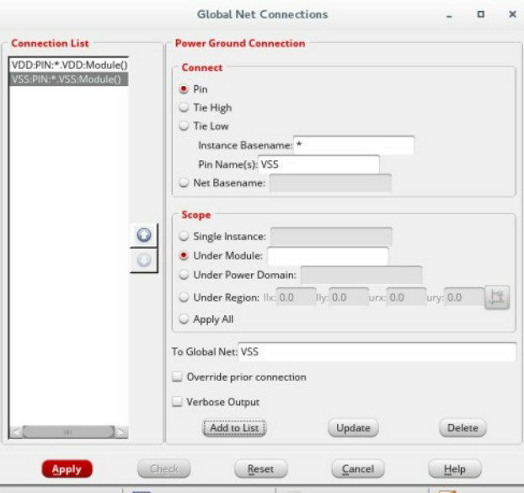

* In order to Tap in Power from a distant Power supply, Wider Nets and Parallel connections improve efficiency. Moreover, the cells that would be placed inside the core area are expected to have shorter Nets for lower resistance.
* Hence Power Rings [Around Core Boundary] and Power Stripes [Across Core Boundary] are added which satisfies the above conditions.
* Select Power → Power Planning → Add Rings to add Power rings ‘around Core Boundary’.

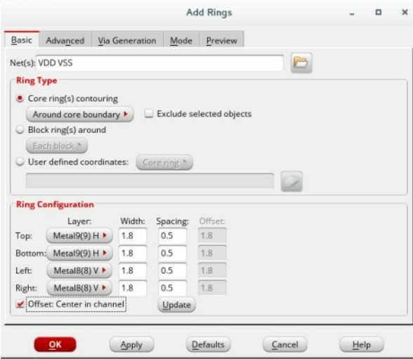

* Select the Nets from Browse option OR Directly type in the Global Net Names separated by a space being Case and Spelling Sensitive.
* Select the Highest Metals marked ‘H’ [Horizontal] for Top and Bottom and Metals marked ‘V’ [Vertical] for Right and Bottom. This is because Highest metals have Highest Widths and thus Lowest Resistance.
* Click on Update after the selection and “Set Offset : Centre in Channel” in order to get the Minimum Width and Minimum Spacing of the corresponding Metals and then Click “OK”.
* Similarly, Power Stripes are added using similar content to that of Power Rings.

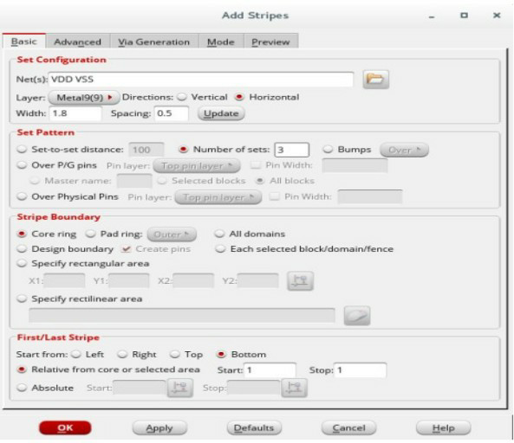

Factors to be considered under Power Stripes :

→ Nets

→ Metal and It’s Direction

→ Width and Spacing [Updated]

→ Set to Set Distance = ( Minimum Width of Metal + Min. Spacing ) x 2

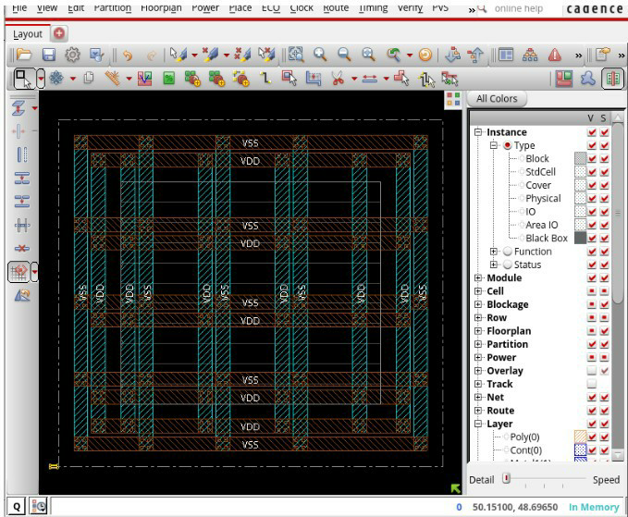

* On adding Power Stripes, The Power mesh setup is complete as shown. However, There are no Vias that could connect Metal 9 or Metal 8 directly with Metal 1 [VDD or VSS of Standard Cells are generally made up of Metal 1].
* The connection between the Highest and Lowest Metals is done through Stacking of Vias done using “Special Route”.
* To perform Special Route, Select Route → Special Route → Add Nets → OK.
* After the Special Route is complete, all the Standard Cell Rows turn to the Color coded for Metal 1 as shown below.

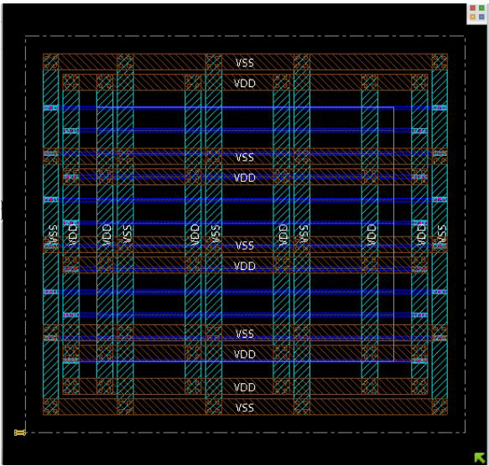

The complete Power Planning process makes sure Every Standard Cell receives enough power to operate smoothly.

→ **Pre – Placement** :

* After Power Planning, a few Physical Cells are added namely, End Caps and Well Taps.

End Caps : They are Physical Cells which are added to the Left and Right Core Boundaries acting as blockages to avoid Standard Cells from moving out of boundary.

Well Taps : They act like Shunt Resistance to avoid Latch Up effects.

To add End Caps, Select Place → Physical Cell → Add End Caps and “Select” the FILL’s from the available list.

* Higher Fills have Higher Widths. As shown Below, The End Caps are added below your Power Mesh.

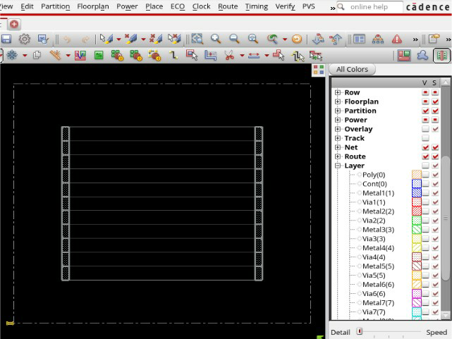

* To add Well Taps, Select Place → Physical Cell → Add Well Tap → Select →FillX [X → Strength of Fill = 1,2,4 etc] → Distance Interval [Could be given in range of 30-45u] → OK

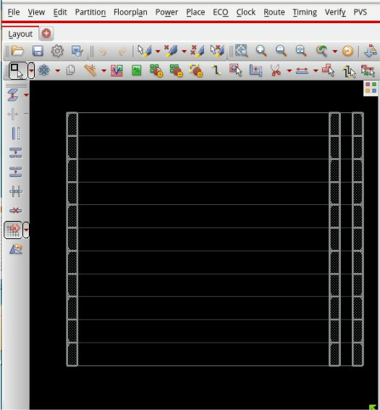

→ **Placement**

1. The Placement stage deals with Placing of Standard Cells as well as Pins.
2. Select Place → Place Standard Cell → Run Full Placement → Mode

→ Enable ‘Place I/O Pins’ → OK → OK .

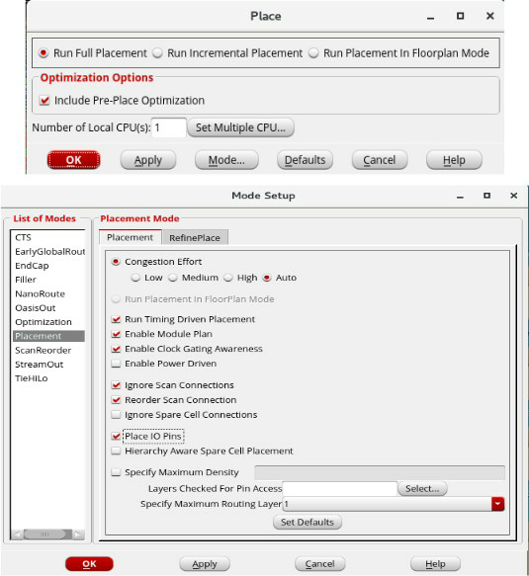

* All the Standard Cells and Pins are placed as per the communication between them, i.e., Two communicating Cells are placed as close as possible so that shorter Net lengths can be used for connections as Shorter Net Lengths enable Better Timing Results.

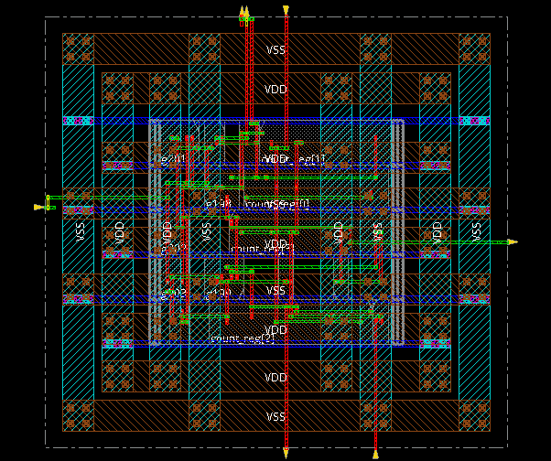

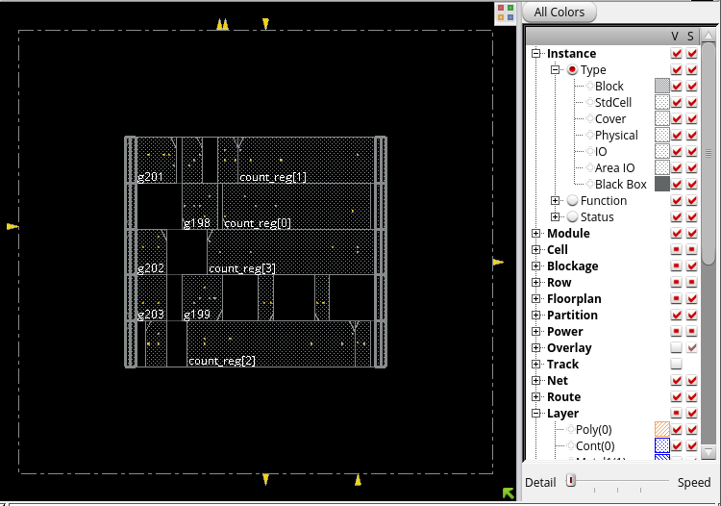

You can toggle the Layer Visibility from the list on the Right. The List of Layers available are shown on the right under “Layer” tab with colour coding.

→ Report Generation and Optimization :

1. Timing Report :
   1. To generate Timing Report, Timing → Report Timing → Design Stage – PreCTS
   2. Analysis Type – Setup → OK
   3. The Timing report Summary can be seen on the Terminal.
2. Area Report :
   1. **cmd :** report_area
3. Power Report :
   1. **cmd :** report_power

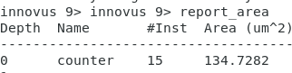

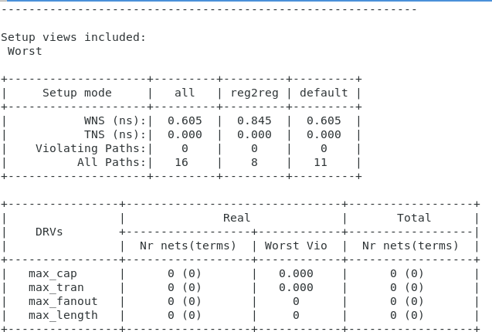

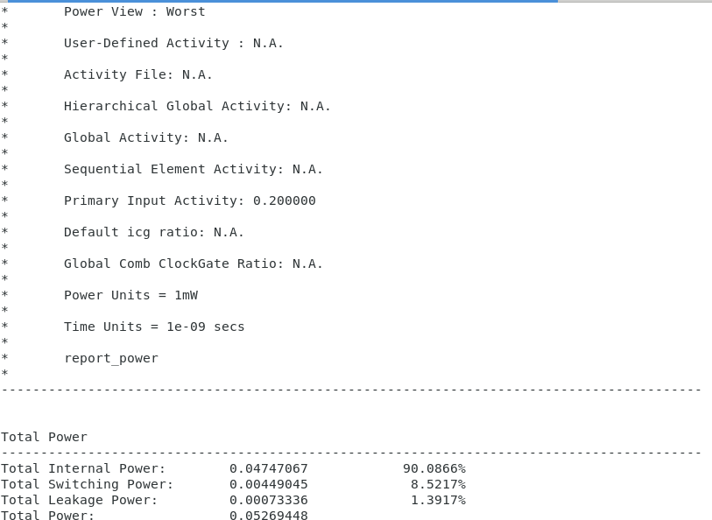

* In case of any Violating paths, the design could be optimized in the following way.
* To optimize the Design, **Select ECO → Optimize Design → Design Stage [PreCTS] → Optimization Type – Setup → OK**

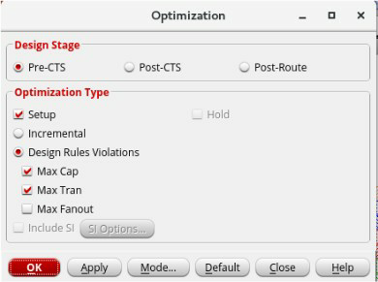

* After you run the optimization, the terminal displays the latest Timing report and updated area and power reports can be checked.
* This step Optimizes your design in terms of Timing, Area and Power. You can Generate Timing, Area, Power in similar way as above report Post – Optimization to compare the Reports.

**Clock Tree Synthesis**

* The CTS Stage is meant to build a Clock Distribution Network such that every Register (Flip Flop) acquires Clock at the same time (Atleast Approximately) to keep them in proper communication.
* A Script can be used to Build the Clock Tree as follows :

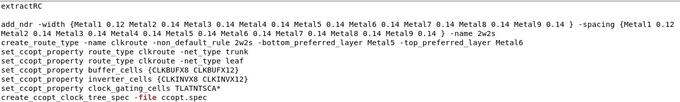

* Source the Script as shown in the above snapshot through the Terminal and then Select Clock → CCOpt Clock Tree Debugger → OK to build and view clock tree.

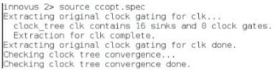

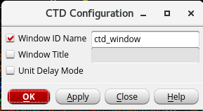

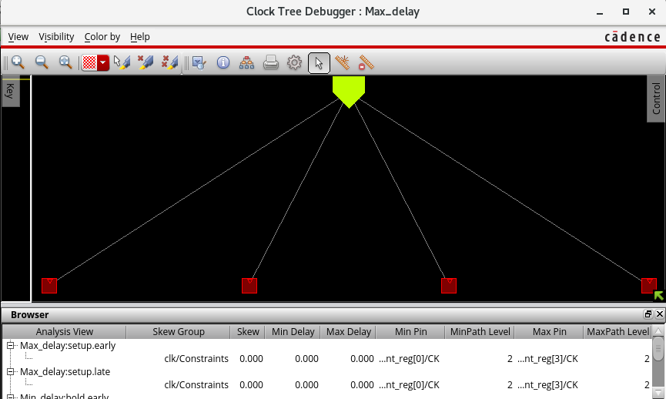

* The Red Boxes are the Clock Pins of various Flip Flops in the Design while Yellow Pentagon on the top represents Clock Source.
* The Clock Tree is built with Clock Buffers and Clock Inverters added to boost up the Clock Signal.

Report Generation and Design Optimization :

* CTS Stage adds real clock into the Design and hence “Hold” Analysis also becomes prominent. Hence, Optimizations can be done for both Setup & Hold, Timing Reports are to be Generated for Setup and Hold Individually.

Setup Timing Analysis :

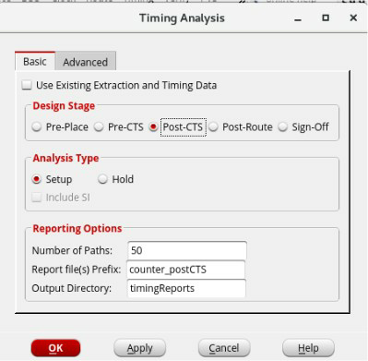

Hold Timing Analysis :

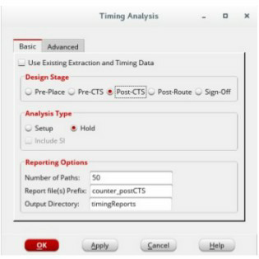

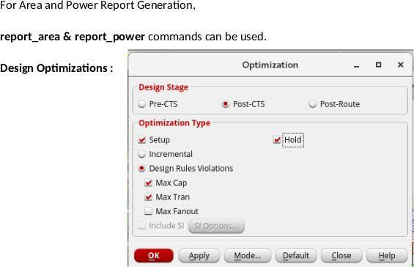

**Routing :**

1. All the net connections shown in the GUI till CTS are only based on the Logical connectivity.
2. These connections are to be replaced with real Metals avoiding Opens, Shorts, Signal Integrity [Cross Talks], Antenna Violations etc.
3. To run Routing, Select Route → Nano Route → Route and enable Timing Driven and SI Driven for Design Physical Efficiency and Reliability.

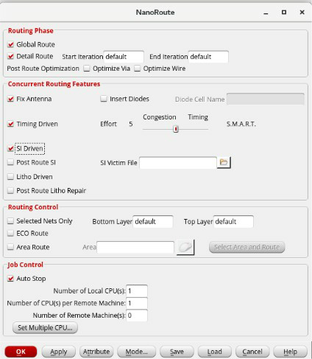

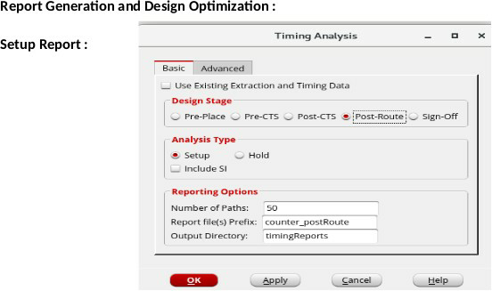

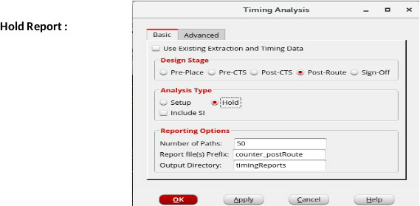

**Area and Power Reports :**

Use the commands report_area and report_power for Area and Power Reports respectively.

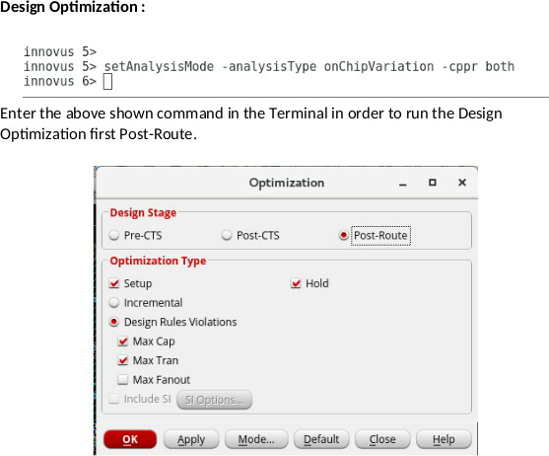

* As an alternate to the setAnalysisMode command, you can use the GUI at Tools → Set Mode → Set Analysis Mode → Select On-Chip- Variation and CPPR.
* The Report generation is same as shown prior to Design Optimization.

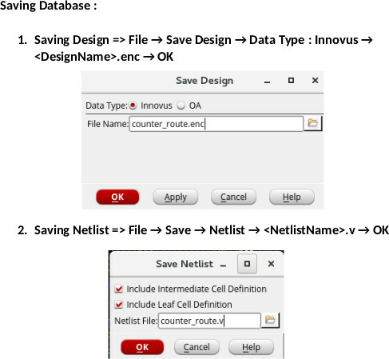

**It is recommended to save Netlist and Design at every stage.**

**To restore a Design Data Base, type source <DesignName>.enc in the terminal.**

**GDS File Generation**

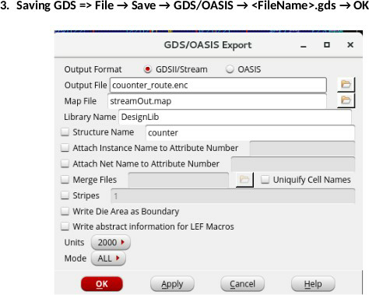

**Physical Verification – Capturing DRC and LVS :**

* After saving the routed Database, you can proceed for Physical Verification and capture the DRC and LVS reports.
* Inputs Required – DRC :
* Technology Library and Rule Set
* GDS format giles of all Standard Cells (Given by Cadence at

/home/install/FOUNDRY/90nm/dig/gds for 90nm Tech node)

* Outputs – DRC :
* DRC Violation Report
* Physical Netlist (Optional)

From the Innovus GUI, select PVS → Run DRC to open the “DRC Submission Form”.

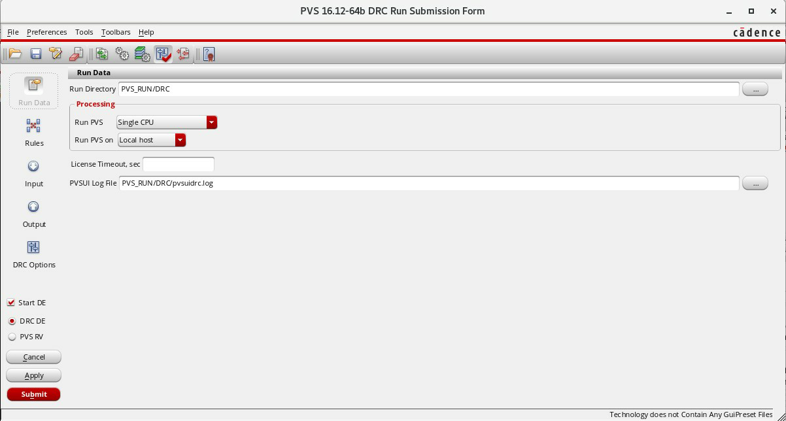

The DRC Run Submission Form begins with mentioning the Run Directory. The Run Directory is the location where all the logs, reports and other files concerned with PVS are saved.

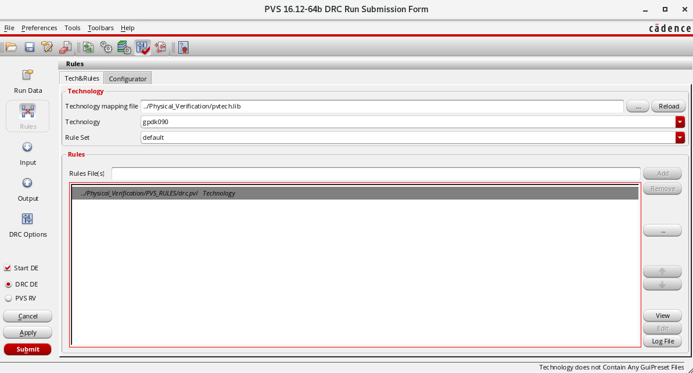

The technology Library is to be loaded under “Rules tab”.

* The Technology Library is specific for PVS Tool and technology node on which the design is created.
* On reading the tech lib, the rule set is loaded and the corresponding fabrication rules are read in to be checked against the design.



* The GDS format files of all standard cells available with the corresponding technology node are also provided by the vendor. Select all of them to add.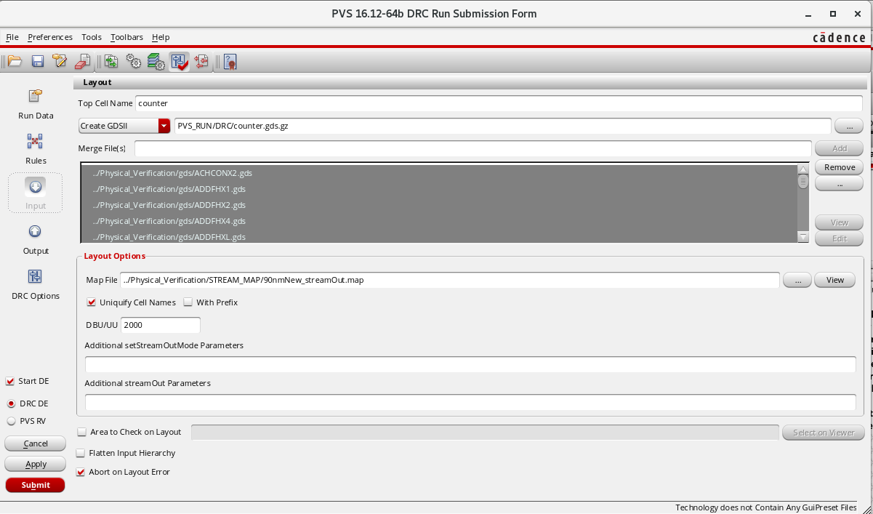
* The output report can be named and saved as shown.

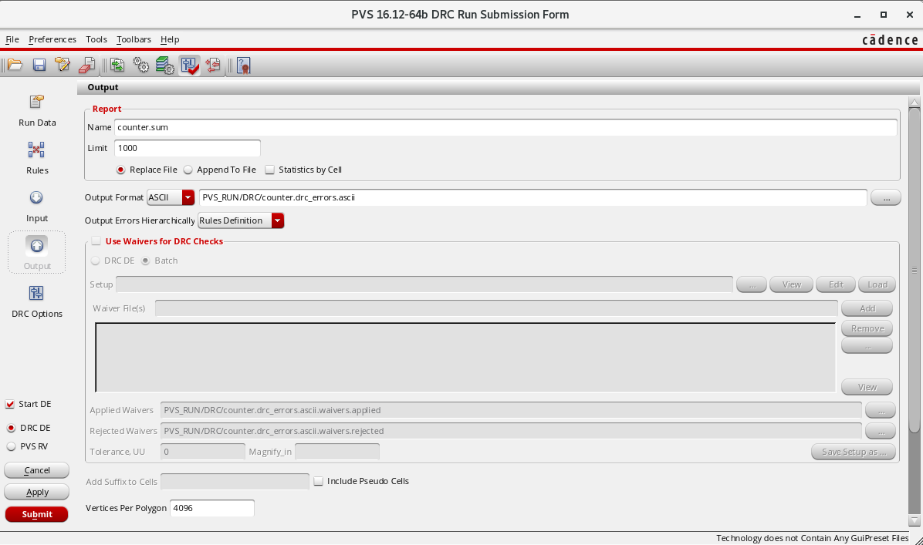

* Hit “Submit” to run the DRC and the following windows appear.

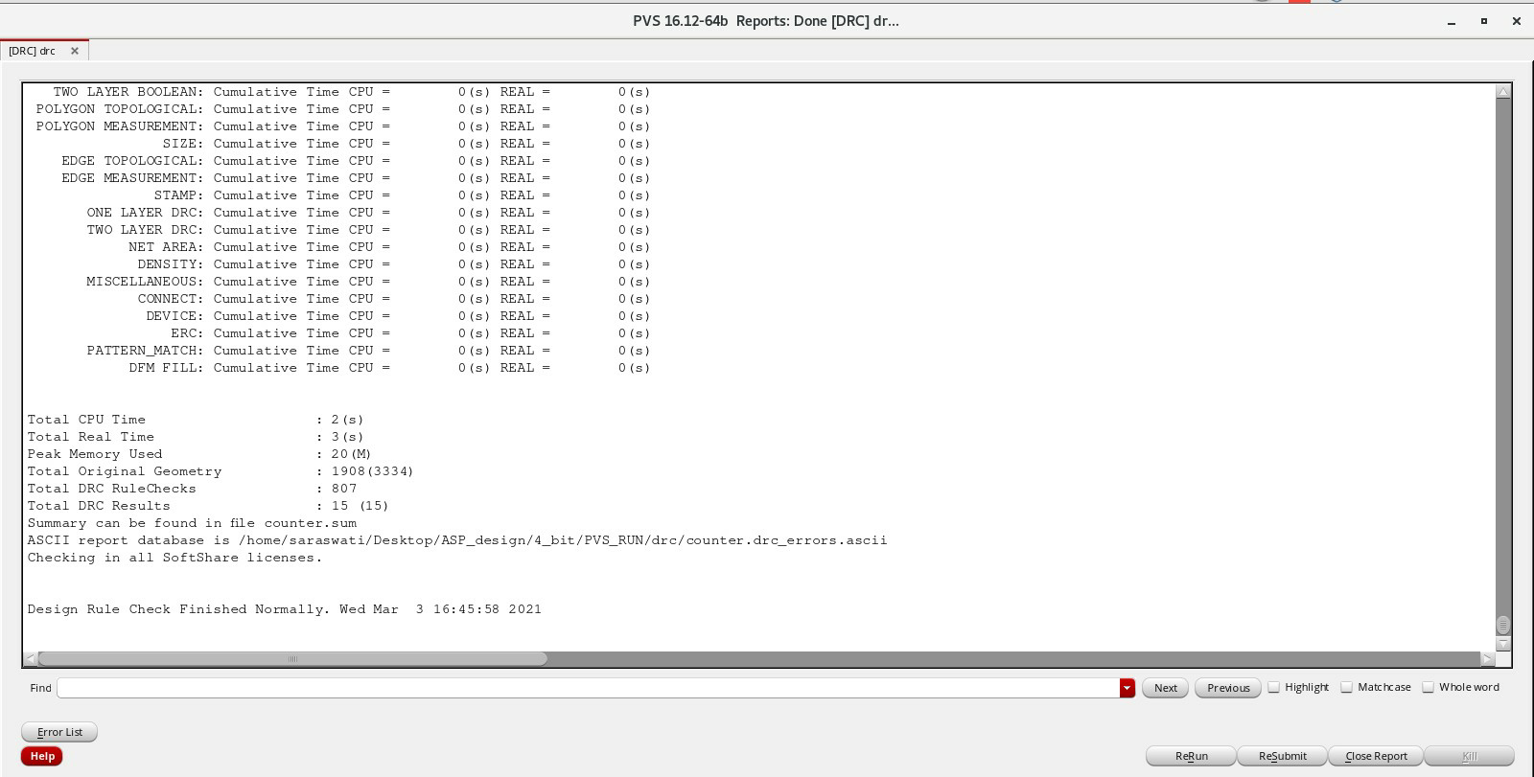

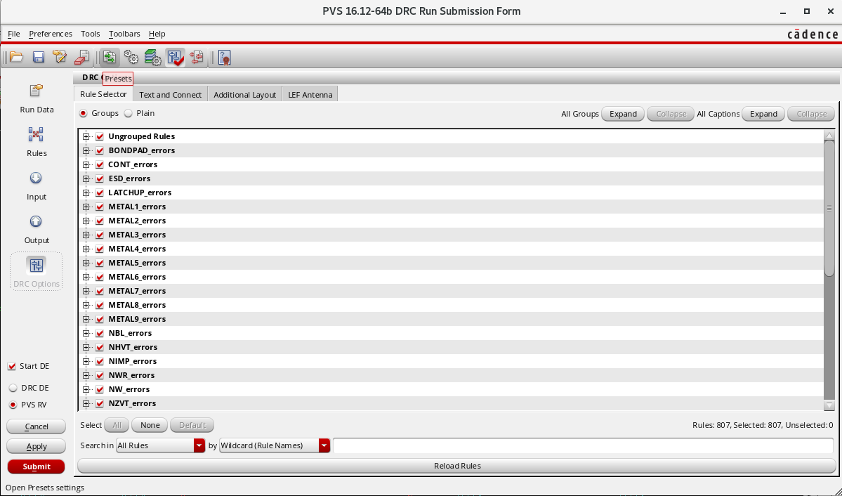

* All the list of DRC Errors can be seen in the above window of which the location of the DRC Violation occuring can be highlighted dealing one to one.

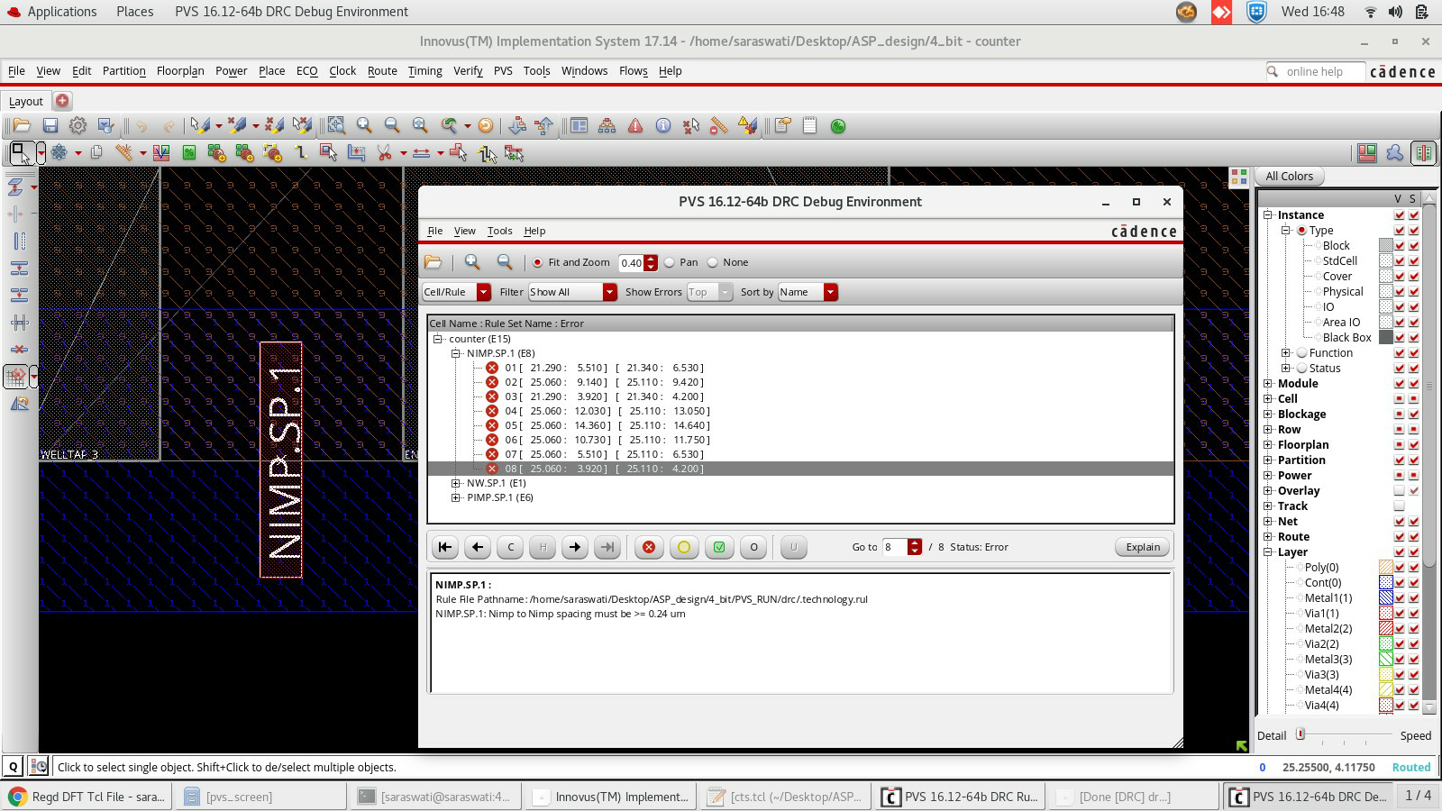

* For example, in the above shown snapshot, the errors associated with N-Implant can be seen. (Select a error occurrence and click on the right arrow below to highlight/zoom in the location.)
* You can save the DRC Run as a “Preset” file to rerun the DRC if required at a later point of time.
* Saving/loading the Preset File is shown below.

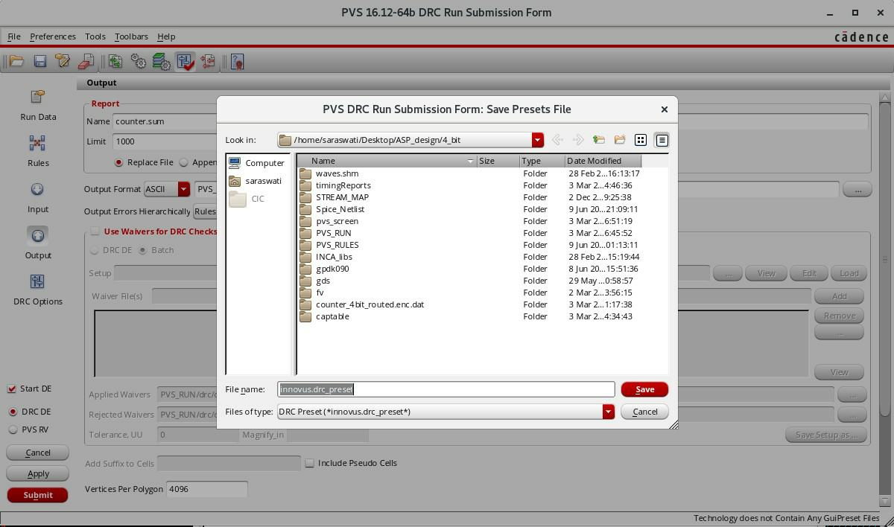

* Loading a Preset file is shown below.

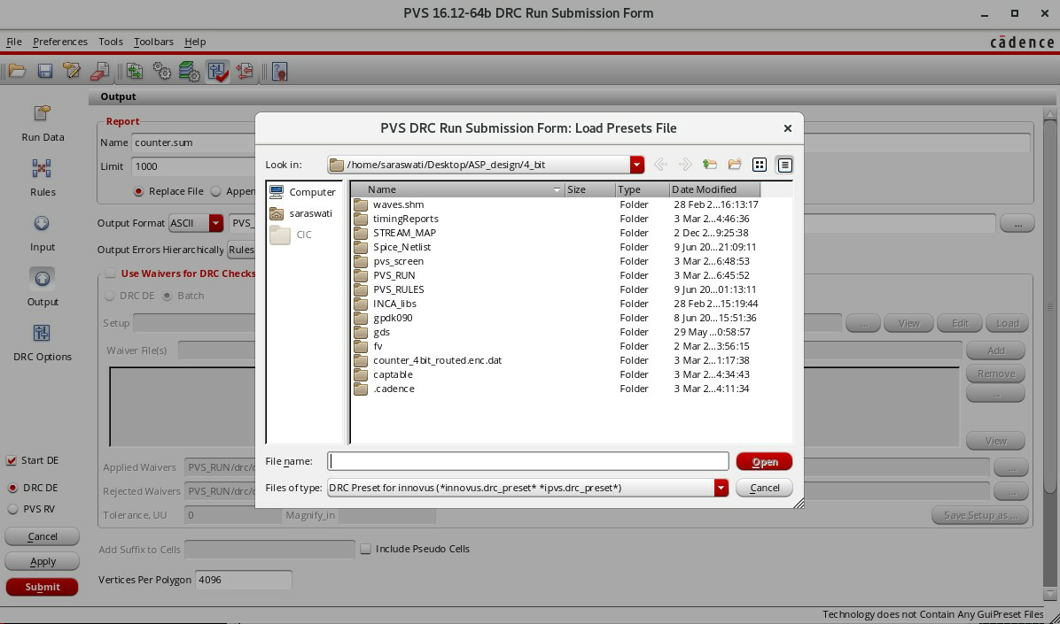

**Note :** A Physical Netlist can be saved after the DRC Run as shown below.

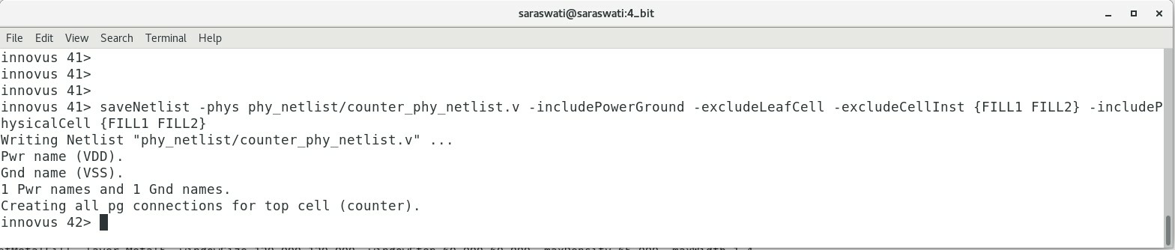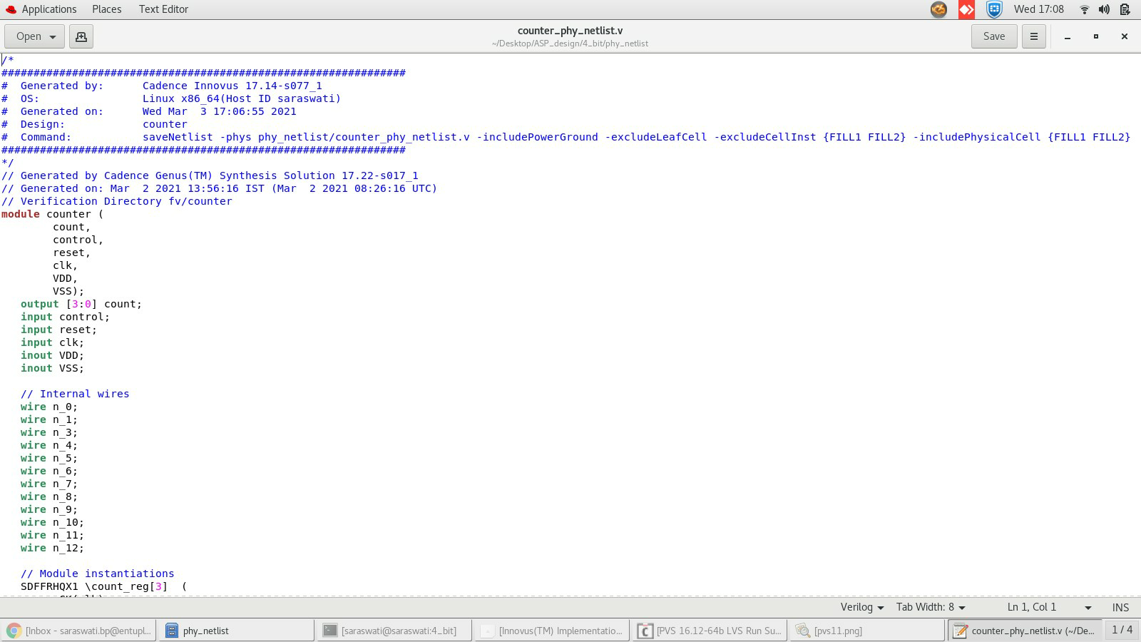

* Inputs Required – LVS :
  + Technology Library
  + Standard Cell GDS Files
  + Spice Netlist of all Standard Cells (Provided by Library Vendor)
* Outputs – LVS :
  + LVS Match/Mismatch Report
* From the Innovus GUI, Select PVS → Run LVS to open the LVS run submission form.

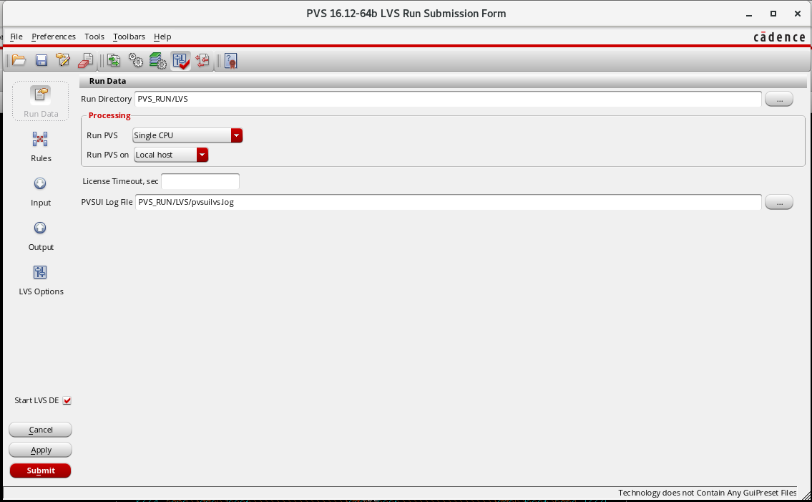

* Provide the Run directory and log file name (Along with path – Optional)
* Load the Tech Lib, GDS Files and Spice Netlist of all Standard Cells under the corresponding technology node.

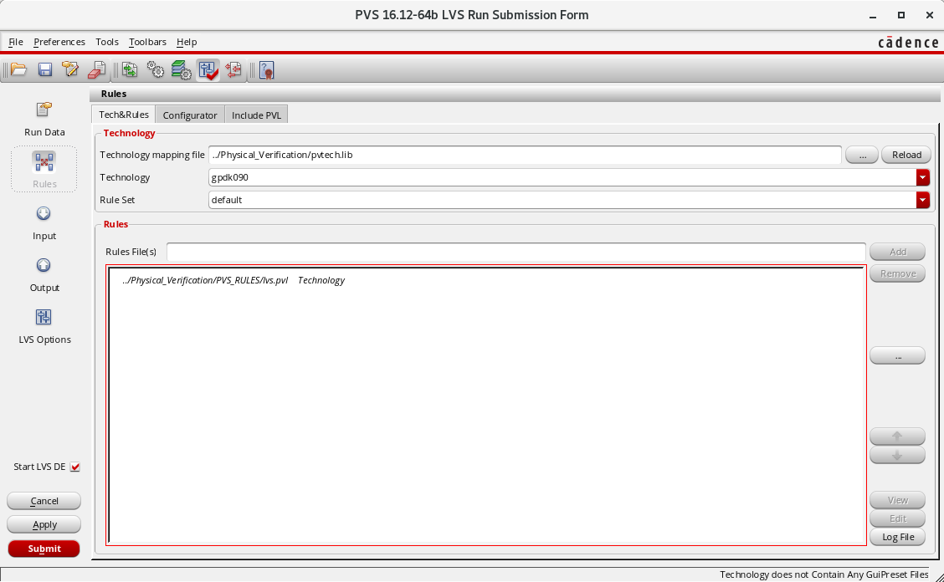

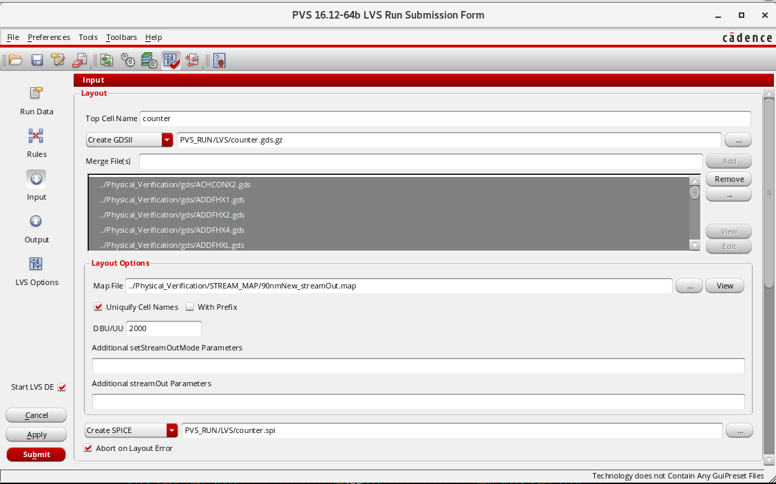

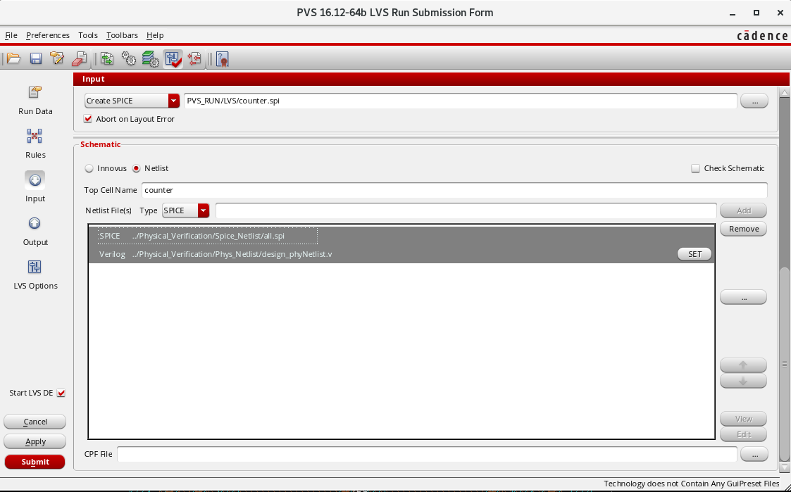

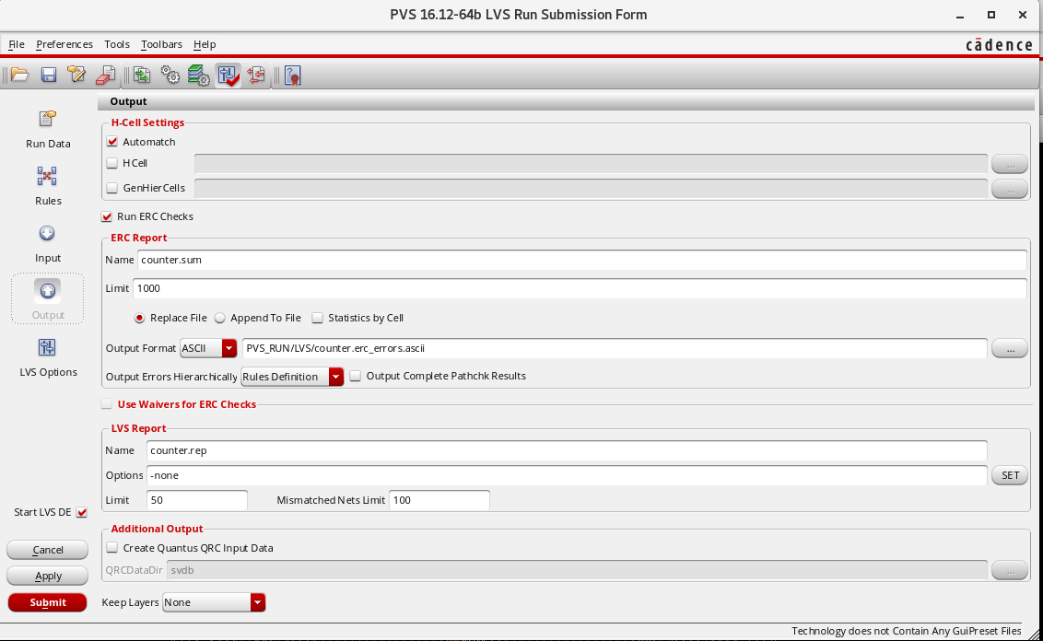

* On successful completion of LVS Run, the following windows appear.

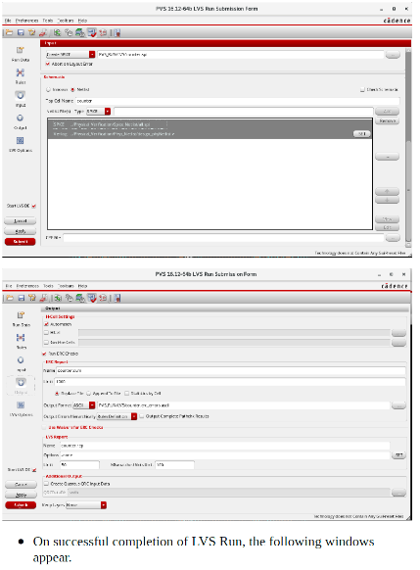

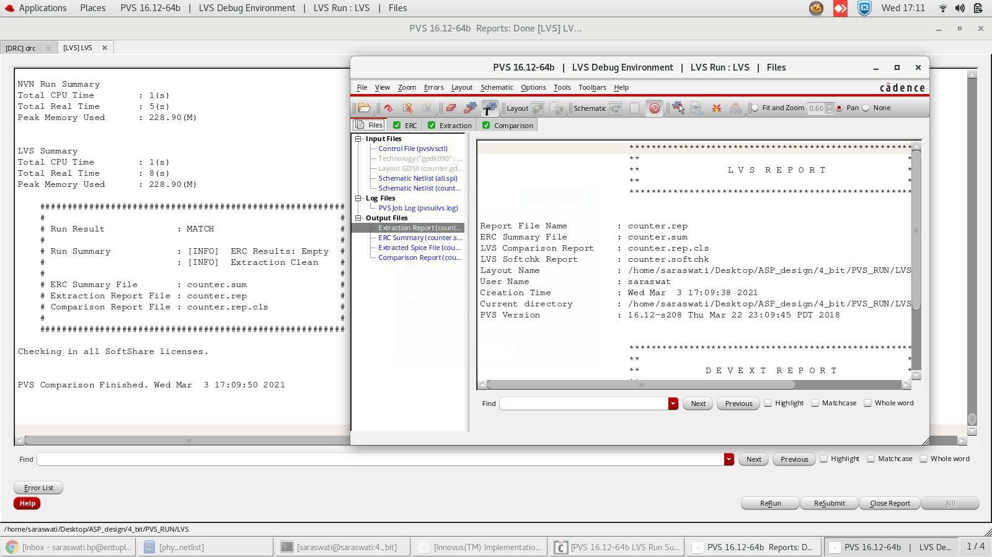

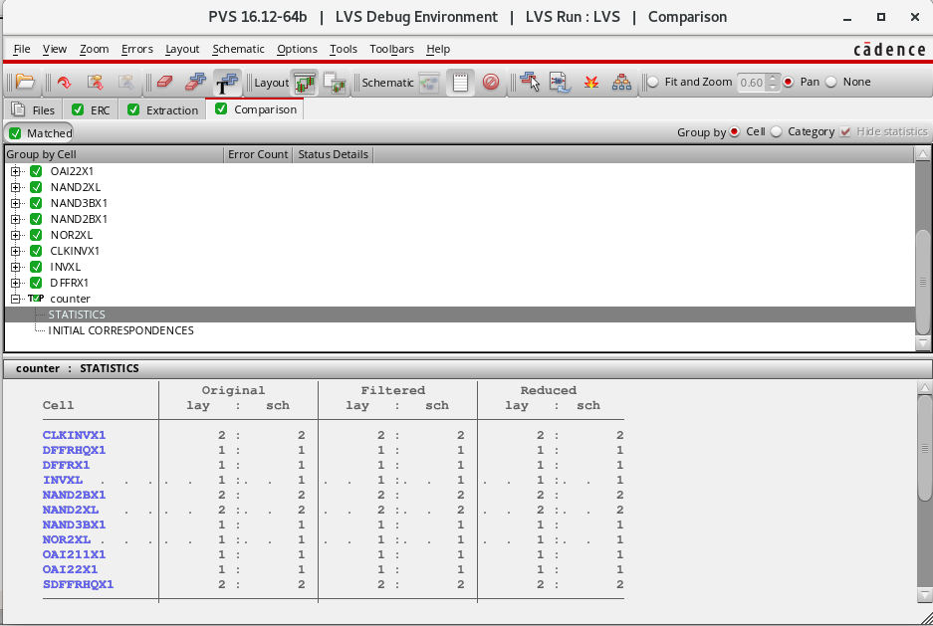

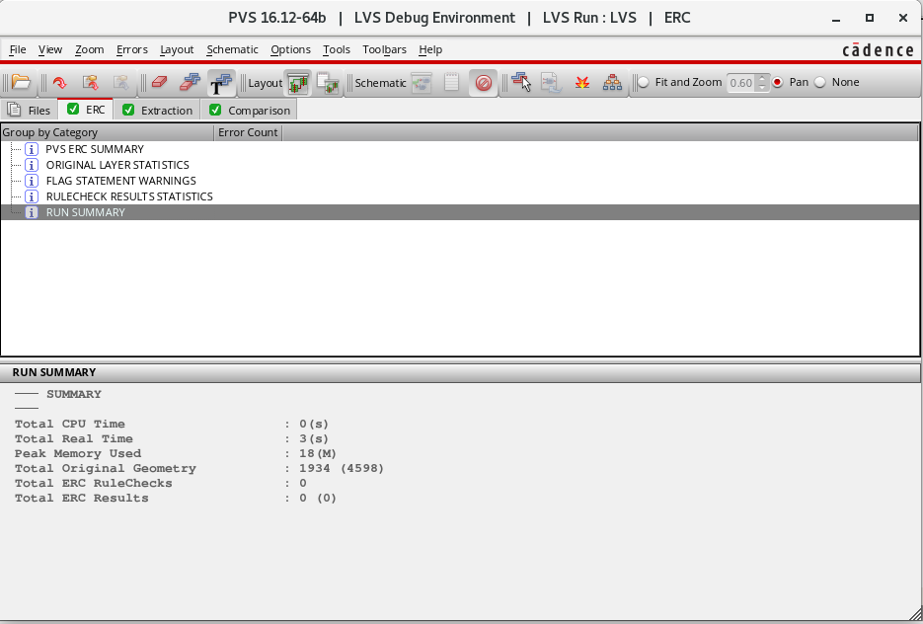

* You can create a GDS file along with Stream out file either using the GUI as File → Save → GDS/Oasis or use the following command.
* **Cmd :** streamOut <GDSFileName>.gds -streamOut

<streamOut>.map